## Base and NavBar html

<html lang="en">

  <head>

    <meta charset="UTF-8" />

    <meta name="viewport" content="width=device-width, initial-scale=1.0" />

    <link rel="stylesheet" href="css\style.css" />

    <link

      rel="stylesheet"

      href="https://cdnjs.cloudflare.com/ajax/libs/font-awesome/5.15.1/css/all.min.css"

      integrity="sha512-+4zCK9k+qNFUR5X+cKL9EIR+ZOhtIloNl9GIKS57V1MyNsYpYcUrUeQc9vNfzsWfV28IaLL3i96P9sdNyeRssA=="

      crossorigin="anonymous"

    />

    <title>Loduki | Cloud Hosting For Everyone</title>

  </head>

  <body>

    <!--NavBar-->

    <div class="navBar">

      <div class="container">

        <h1 class="logo">Loruki.</h1>

        <nav>

          <ul>

            <li><a href="index.html">Home</a></li>

            <li><a href="features.html">Features</a></li>

            <li><a href="docs.html">Docs</a></li>

          </ul>

        </nav>

      </div>

    </div>

  </body>

</html>

We want to have a Div with the class o the NavBar, and it will hold the logo and the menu (navigation).

Wrap the logo in a separate container in order to give the logo a max width so it does not stretch all over the browser.

## Using google fonts

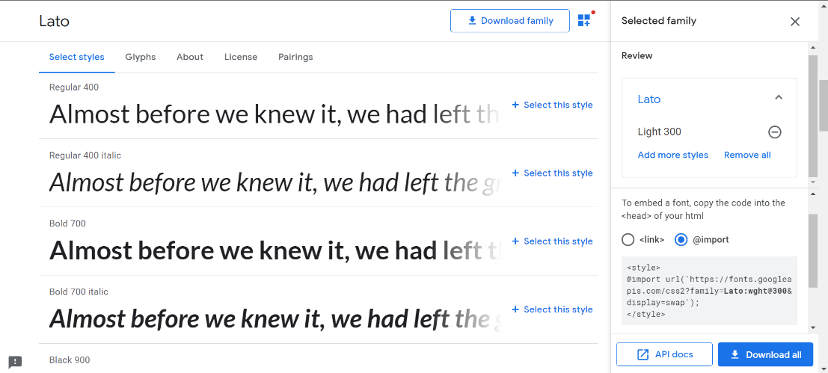Downloading fonts from **google-fonts.** Note that if you want to import a font in the html, you would use the <link> method of embeding the font inside the <head> tag/ Alternatively, you can embed the font by copying the **@import** syntax, and pasting it inside your style.css file.

## Using **cdnjs.com** libraries

Just like with google fonts, simply search for the font you want to use/import, then select your prefered anchor. Here we have **url, link-tag, and SRI-hash.** And place them in the appropriate file. (you know this stuff, dawg! :3 )

## Styling Images so they fit inside a container

It is useful to place images into separate conteainners for each-single-image, so that we can set the image **width: 100%;** to the width of the parent container. This means that we now only have to worry about the size and position of the container (not the image inside it). Since the img will always adapt to fit 100% of its parent;

img {

  width: 100%; /*Keeps the images within their container*/

}

### Simple CSS reset

* {

  box-sizing: bored-box; /*padding and margin don't increase width*/

  padding: 0;

  margin: 0; /*deleting padding and margin on everything*/

}

/*Setting the font,text color and line spacing for our pages*/

body {

  font-family: "Lato", sans-serif;

  color: #333;

  line-height: 1.6; /*To make everyhitng spread out a little*/

}

/*Deleting the default styles for <ul>,<a> elements */

ul {

  list-style-type: none;

}

a {

  text-decoration: none;

  color: #333;

}

### **Creating a nav bar with the logo on one side, and link <ul> elements on the opposite side.**

1. Create the navBar itself
2. Put all the elements (logo/UL) inside the <nav> in a separate container <div class=”navElements”>
3. Give the container the full width and height of it’s nav parent(height/width: 100%)
4. Assign a display-flex to the container containing the the Logo/ul .navElements{display:flex;}
5. 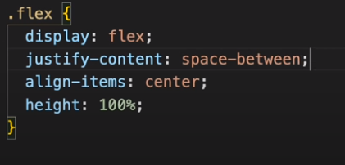In order to separate the two flex-elements inside the nav (logo, ul/links) apply a **justfy-content: space-between;** property that will put all unassigned space within the container between the two flex elements
6. Center align the elements vertically (**align-items:center)**

### **Centering the nav content so that no matter how stretched the webpage gets, the nav stays in the center of the browser**

1. Give the container that contains your nav elements a fixed max-width, so that it does not stretch beyond a certain point. This will make it stick to the left of the nav, by default
2. Now set its margins to 0/auto, to make it stick to the center, instead of the left
3. Feel free to add **overflow: auto;** if any elements are sticking out of the conteainer, and you want the container to grow and wrap over it.

### **Using classes to assign display:flex and display:grid generic rules to html elements**

**Note how we want to create generic(flex/grid)classes to be able to assign them to various elements as we need it, so that we don’t have to write/rewrite those container/flex definitions for each element seperately.**

**As a side note, if it happens that we need a more specific grid/flex rule, we would just target the element-class together with the flex/grid-class and build rules for those**

**.elementClass.grid{specific-rules}**

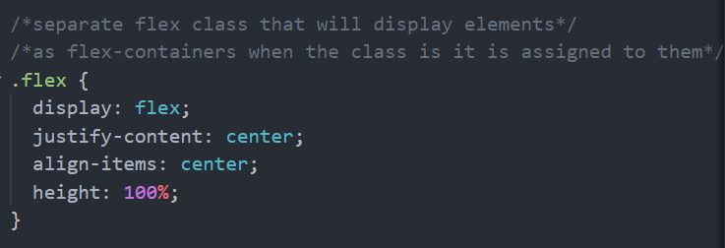

## Nav Bar html and styling (finished code)

CSS

/*NavBar(Bar) that will stretch all the way across the page*/

.navBar {

  background-color: #047aed;

  color: #fff;

  height: 70px; /*fixed height of the nav_bar*/

}

/*styles ul tag-elements inside said class container*/

.navBar ul {

  display: flex;

}

.navBar a {

  color: #fff;

  padding: 10px;

  margin: 0 5px;

}

/*adds a border when hovering over any <a> of the parent class*/

.navBar a:hover {

  border-bottom: 2px #fff solid;

}

/*adds rules to any elements that have both of these classes*/

.container.flex {/*note that there is no space between class names*/

  justify-content: space-between;

}

HTML

 <!--###########NavBar#################-->

    <div class="navBar">

      <div class="container flex">

        <h1 class="logo">Loruki.</h1>

        <nav>

          <ul>

            <li><a href="index.html">Home</a></li>

            <li><a href="features.html">Features</a></li>

            <li><a href="docs.html">Docs</a></li>

          </ul>

        </nav>

      </div>

    </div>

**CSS utility classes used to style the nav**

/*#######UTILITIES##########*/

/*Global/general classes we will use throughout the website*/

/*Container that will keep the navBar content in the middle*/

.container {

  max-width: 1100px;

  margin: 0 auto; /*This center the content inside the nav*/

  overflow: auto;

  /*Nav will wrap over any elements that spill out the container*/

  padding: 0 40px;

}

/*separate flex class that will display elements*/

/*as flex-containers when the class is it is assigned to them*/

.flex {

  display: flex;

  justify-content: center;

  align-items: center;

  height: 100%;

}

### Styling a card within a section element using overflow:visible

**The effect:**

### 

/*customizing our general 'grid-class' */

.showcase .grid {

  overflow: visible;

  grid-template-columns: 55% 45%;

  gap: 30px;

}

.showcase-form {

  position: relative; /*position 'relative'*/

  /*in order to use top/bottom properties*/

  top: 60px;

  height: 350px; /*make the child element overflow*/

}

Inside the card element we positioned a child <div class =”showcase-form”>, now, since we want our card element to inch past our ‘showcase’ container, we will make the card element grow larger than the container (height 350px), and and then to make the overflow visible, we will set the **overflow: visible;** rule to the parent container so that it allows elements within it, to spill outside its borders and remain visible.

Postanska stedionica: 200 123 07 37 20 50 Novi Obradov Racun

# Creating a skew for a section

This is done. By basically adding a separate element, inserted as the first/last or both, child of the parent element

In CSS, **::after** creates a [pseudo-element](https://developer.mozilla.org/en-US/docs/Web/CSS/Pseudo-elements) that is the last child of the selected element. It is often used to add cosmetic content to an element with the [content](https://developer.mozilla.org/en-US/docs/Web/CSS/content) property. It is inline by default.

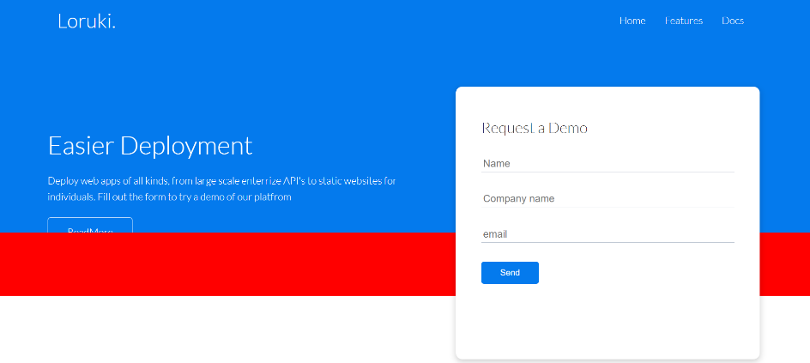Here we made an element that is the last child of our “showcase” class. To make it display we have given it a height, set its position to absolute(in order to move it around the parent “relative” parent element) and assigned it the positioning **bottom:0 left 0,** to start at the bottom left of the parent.

After defining the width and height, the element will display (otherwise it is an empty container without a dimention to display and as such it is squished too tiny to see (invisible actually). After we’re able to see it, we will start to work on skewing it.

/*Creating an angle(slant to our showcase section element*/

/*make sure that .showcase has position (relative)*/

.showcase:after {

  content: "";

  /*you have to have a content property  when using before or after*/

  position: absolute;

  /*Element will only appear, if we have defined: height/width */

  /*and top/bottom left and right property value*/

  height: 100px;

width: 100%;

  bottom: 0px;

  left: 0;

  background: red;

  transform: skewY(0deg);

}

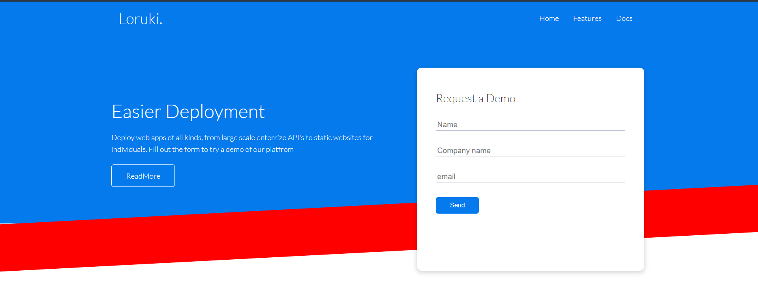

Next we skew the element that we’ve added **:after** by using transform: **skewY(-3deg);**

And finally we change the background color of the **:after** pseudo-element, to **white.**

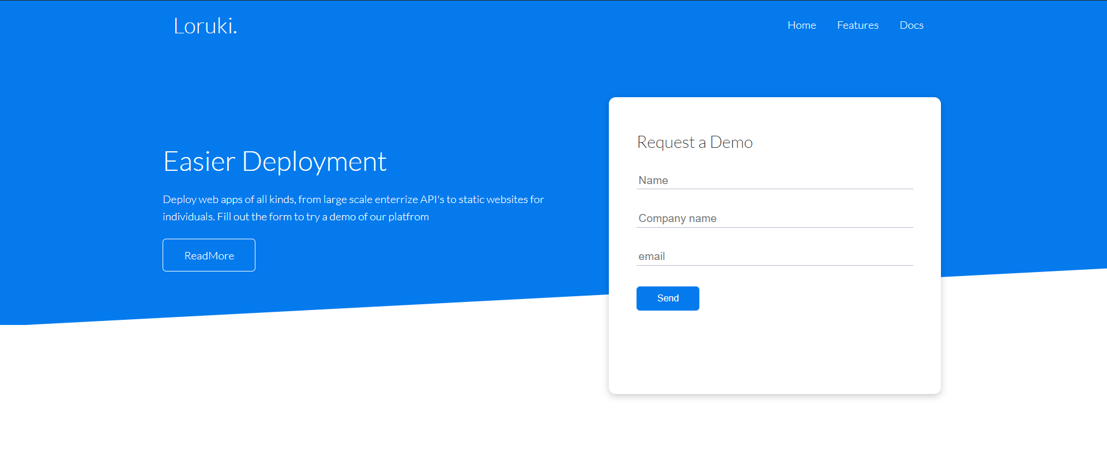

Note that in order for our **:after** pseudo element not to cut into our **ReadMore** button, we’ve added a minus value to the bottom position of our pseudo element, so that it would be moved down, away from the **.showcase** parent.

/*Creating an angle(slant to our showcase section element*/

/*make sure that .showcase has position (relative)*/

.showcase:after {

  content: "";

  position: absolute;

  height: 100px;

  left: 0;

  right: 0;

  bottom: -60;

  background: white;

  transform: skewY(-3deg);

}

### **The concept of utility classes**

**.my-1** {margin: 1, 0; /*margin on the y axis(top-bottom)*/} .**marginY-1** (better name)

.**mx-2** {margin: 0, 2; /*margin on the x axis(left-right)*/

**…**

We add these classes to our elements when we want to give them some predetermined css rules, just so that we would not have to create a selector and write separate rules for every single element we want to add a top/bottom margin of 1px for example.

### **Selecting the first child of a parent element in css**

.parentClass .childClass > *:first-child{

}

What the selector above states is, find me the .childClass (class) from the .parentClass(class) and from all of the elements belonging to the class of “.childClass” (>*) select the first element**. :first-child**

### **Creating a gnarly layout using css-grid**

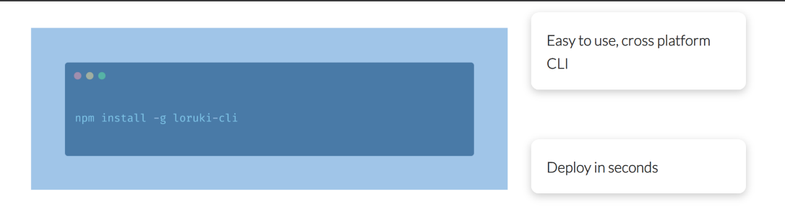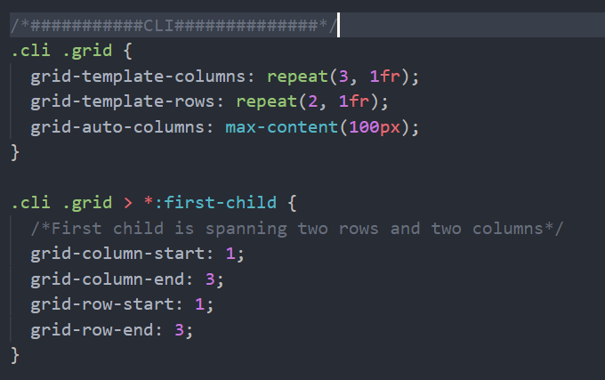

Note that it may seem like the image element taking up two rows and spanning the first two columns is smaller than the grid cells it inhabits. This is just visually, as the element has a significant margin around itself, as can be seen in the image below.

### **Flex wrap property (To make elements immediately responsive)**

When we want our flex elements to be more responsive, we should use the flex-wrap:wrap; property, which instead of squeezing our elements together in a single flex row, makes the elements go to the next line as can be seen below: **Use flex wrap to make navs and columns in a single row responsive without the need to resort to having to use media queries for it.**

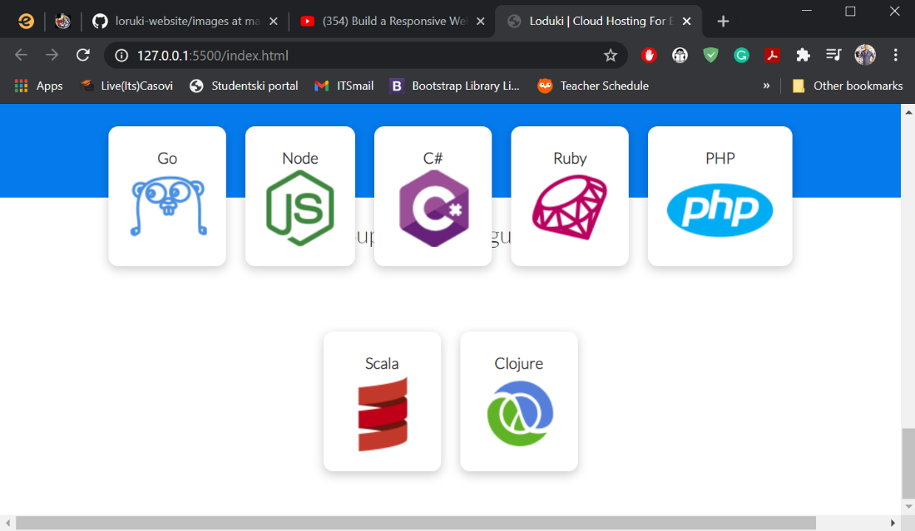

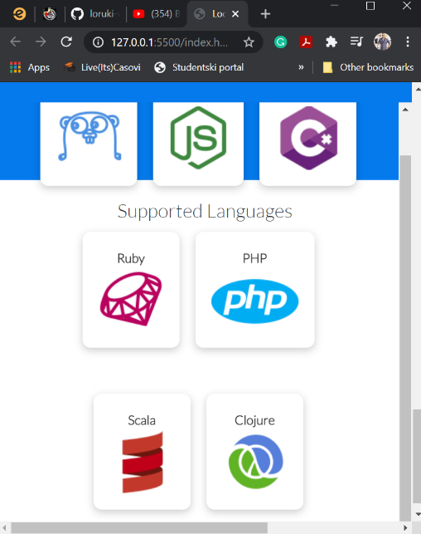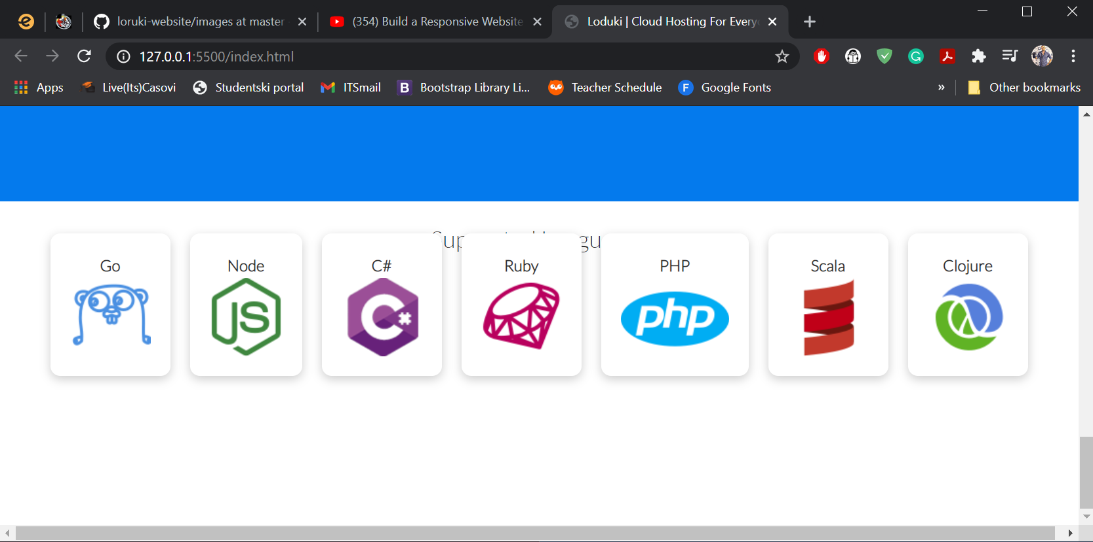

### **Popup hover effect**

.languages .card:hover {

  transform: translateY(-15px);

  /*negative (-Yaxis) moves elements up*/

  /*positive (+Yaxis) moves elements down*/

}

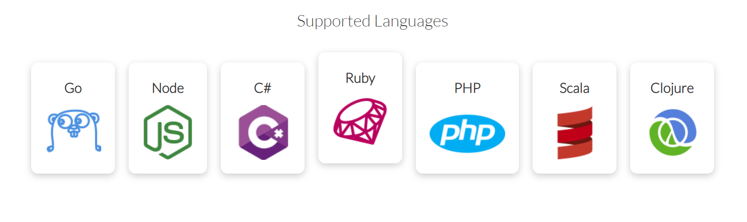

### **Transition effects (animates the transform effect)**

Transition properties are tied to transform effets that are applied to our html elements. If we have, for example, a transform property on our card **(on hover)** {.languages .card:hover }we would target the selector without the **:hover** pseudo class {.languages .card} and add a new rule to that element target itself. (again, without the hover pseudoclass)

.languages .card {

  text-align: center;

  margin: 18px 10px 40px; /*18(top/bottom_ 10left, 40right*/

  transition: transform 0.2s ease-in;

}

.languages .card:hover {

  transform: translateY(-15px);

  /*negative (-Yaxis) moves elements up*/

  /*positive (+Yaxis) moves elements down*/

}

This adds a transition to the transform property(we added on :hover) of 0,2s, so it will take that time for the transform to take place, with the **ease-in** effect, creating the illusion of an animation.

### **Justify content vs Justify self**

**Justify content** is what we use to center-align (left,right or center, actually) all of the content inside our grid of flex container.

**Justify-self** is what we use on the actuall flex/grid-element, when we want to justify/or differently align a single grid/flex element, and not all of them at once.

**Justify-content: center/start/end; 🡪** On the container(justifies all of the child elements)

**Justify-self: center/start/end;** 🡪On the child element(justifies only itself, as the name implies)

### **Assigning the “auto” (value) to a property:**

**Margins:**

For margins this property means to equally divide the margin so that the element rectangle does not approach it’s parent element from any direction in particular. In other words.**Margin: 0 auto**;center aligns the element on the horizontal axis. It will horizontally be in the middle of its parent element. **Margin: auto 0;** on the other hand does the same, but on the vertical Y axis. So it center-aligns the element vertically, or in other words, equally divides the available space on the top and bottom between the element and its parent on the Y –axis, resulting in center-alignment. If the previous stands, it goes to follow that **margin: auto;** is the shorthand to align or evenly divide the empty space around the element on both the Y and X axis, so that the child rectangle would be placed at the very center of its parent rectangle.

**Dimentions(width/height)**

When item dimentions(or element rectangles) are concerned, this value is the default behavior of html element rectangles. Unless the width or height is explicitly declared it is set to **auto.** In other words, It **automatically** stretches or shrinks in order to fit the content (and its margins) placed inside of the element, or lack there of (if there is no content the parent element shrinks into a line without a discernable dimention).

### Note on the layout of our website sections (logical thematic wholes)

<!--#####Head#######-->

    <!--Section Container-->

    <section class="features-head bg-primary py-3">

        <!--Grid container-->

      <div class="container grid">

          <!--First grid element-->

        <div>

          <h1 class="xl">Features</h1>

          <p class="lead">

            Check out the features of Loruki that separate us from the

            competition

          </p>

        </div>

        <!--Second grid element-->

        <img src="images/server.png" alt="" />

      </div>

    </section>

Most website layouts follow this pattern. You come to a thematic whole Header, footer, social, about us, community, contact, etc… And you will for each whole usually create the following

1. A section element with the class describing the web content of said section
2. A flex/grid wrapper for the elements that you will use to define your layout
3. The flex/grid elements themselves, either as normal elements or new container elements in more elements need to to be encapsulated and grouped together in a flexbox or grid cell.
4. Yeah, that’s it. Below you will see a good and telling example of this layout, then the code necessary to achieve it

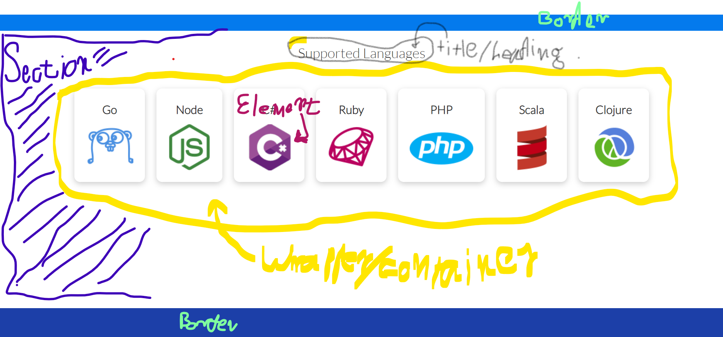

 <!—The name of the logical whole -->

<section class="languages">

<!—The Title of the logical whole -->

  <h2 class="md text-center my-2">Supported Languages </h2>

<!—Container for the elements inside the logical whole -->

  <!--Flex container that will wrap our language cards into one row-->

  <div class="container flex">

      <!—flex element Card1-->

      <div class="card">

        <h4>Go</h4>

        <img src="images\logos\go.png" alt="">

      </div>

      <!-- flex element Card2-->

      <div class="card">

        <h4>Node</h4>

        <img src="images\logos\node.png" alt="">

      </div>

    <!-- flex element Card3-->

    <div class="card">

      <h4>C#</h4>

      <img src="images\logos\csharp.png" alt="">

    </div>

    <!-- flex element Car4-->

    <div class="card">

      <h4>Ruby</h4>

      <img src="images\logos\ruby.png" alt="">

    </div>

    <!-- flex element Card5-->

    <div class="card">

      <h4>PHP</h4>

      <img src="images\logos\php.png" alt="">

    </div>

    <!-- flex element Card6-->

    <div class="card">

      <h4>Scala</h4>

      <img src="images\logos\scala.png" alt="">

    </div>

      <!-- flex element Card7-->

      <div class="card">

        <h4>Clojure</h4>

        <img src="images\logos\clojure.png" alt="">

      </div>

  </div>

</section>

### **Pre-formatted text <pre></pre>**

Figure 1 browser output for our code snippet below

Pre-formated text is going to display exactly as it was written in the html code.

We use it if we want to format the exact text layout within the html code itself, where all of our spaces/line breaks and width between letters, stay exactly as they are in the source html code.

<h3>Requirements</h3>

          <ul>

            <li>Windows 10, Mac OSX, Linux</li>

            <li>Node.js v12 or higher</li>

          </ul>

          <h3>Install</h3>

          <p>Mac (Homebrew)</p>

          <pre><code>$ brew instal loruki-cli</code></pre>

          <p>NPM</p>

          <pre><code>$ brew instal loruki-cli</code></pre>

          <p>Yarn</p>

          <pre><code>$ yarn instal loruki-cli</code></pre>

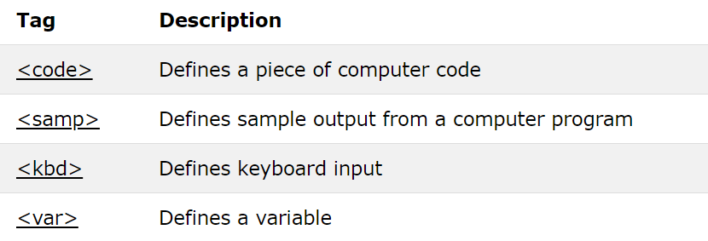Inside these **<pre>** tags we usually insert other tags that define metadata regarding the types of elements we are storing inside the pre-tag, such as:

### Making element height responsive (Appearance of an additional scroll bar troubleshoot)

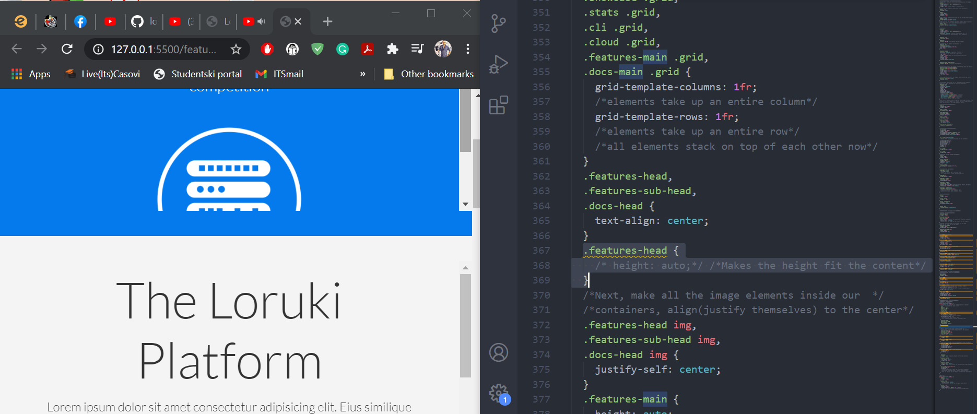

Here we see an example of a problem where one of our section elements appears with an additional scroll-bar in order to display all of its content. This happened as we’ve written a media query for all of our section elements,to stack their elements on top of each other vertically (for mobile) and not horizontally as was the case in the wide display for the desktop.

This means that the content can no longer fit the previous rule of **section**  having the height of 300px. And because of this a scroll bar appears, in order to help the user access all of the content, that basically overflowed the 300px container height for the **.features-headb** section.

How can we fix this, without again arbitrarily assigning a new px height, which might on an even smaller display again be unable to fit all the content vertically?

Well, first we must think whether we actually ever want the size of our sections to be pixel-fixed.

**Height: auto;** 🡪 sets the height of the section/div to exactly fit the content placed inside it.

Incidentaly, that is excatly how we solve the problem of the scroll bar appearing, from having too little vertical room to display the content inside the **features-head** section

Simply set the height to auto, and the section will stretch vertically to fit the content inside of it, and the scroll bar will dissappear.

**(Takeaway… use the height:auto; property value when possible)**

The solution result 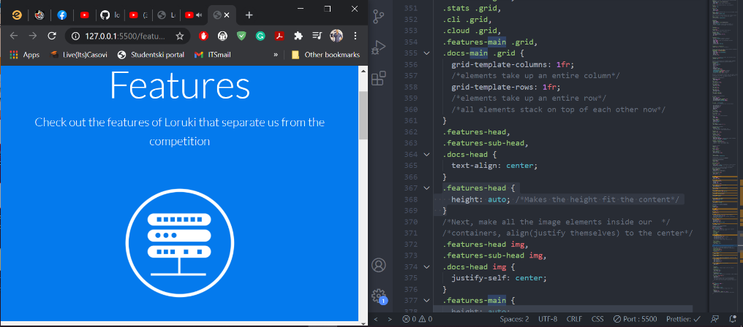🡪

## Building Animations Using CSS

/*######ANIMATIONS#######*/

@keyframes *slideInFromLeft* {

  0% {

    transform: translateX(-100%);

  }

  100% {

    transform: translateX(0);

  }

}

@keyframes *slideInFromRight* {

  0% {

    transform: translateX(100%);

  }

  100% {

    transform: translateX(0);

  }

}

@keyframes *slideInFromTop* {

  0% {

    transform: translateY(-100%);/*moves element it’s whole height to the top*/

  }

  100% {

    transform: translateY(0);/*returns element to its original position*/

  }

}

@keyframes *slideInFromBottom* {

  0% {

    transform: translateY(100%);

  }

  100% {

    transform: translateY(0);

  }

}

### Applying animations to elements:

.showcase-text {

  /*Animation*/

  animation: slideInFromLeft 1s ease-in;

}

# **Deploying our website to Netlify**

Watch: <https://www.youtube.com/watch?v=p0bGHP-PXD4>

1h:56min

# **Arch Architects project**

1.Create the website using the layout of nicepage.com website template

2.Add css animations

3.Create a navBar that will have sticky(slide navigation to any of the sections)

4.Create a tabbed component.

5.Make the navigation sticky using Javascript

6.Add a slider component

7.Create the dynamic reduction of opacity on navBar menu when the user hovers over it(using javascript)

**In other words, first re-create the website as is on the nicepage.com then add some css animations, and then insert all of the Javascript bells and whistles that you;ve learned when practicing javascript.**

**T**he content on the bottom of thewhite section is actually content that belongs to the white section yet is inside a container that overflows. (.whiteSection{oveflow:visible))

The top of the white section can be two elements in one grid/flex wrapper.

The bottom of the white section has a container, in it an h1 a wrapper element containing three divs all of which contain an img, heading, paragraph and an anchor.

## **Building a striped harmonica curtain, with animations**

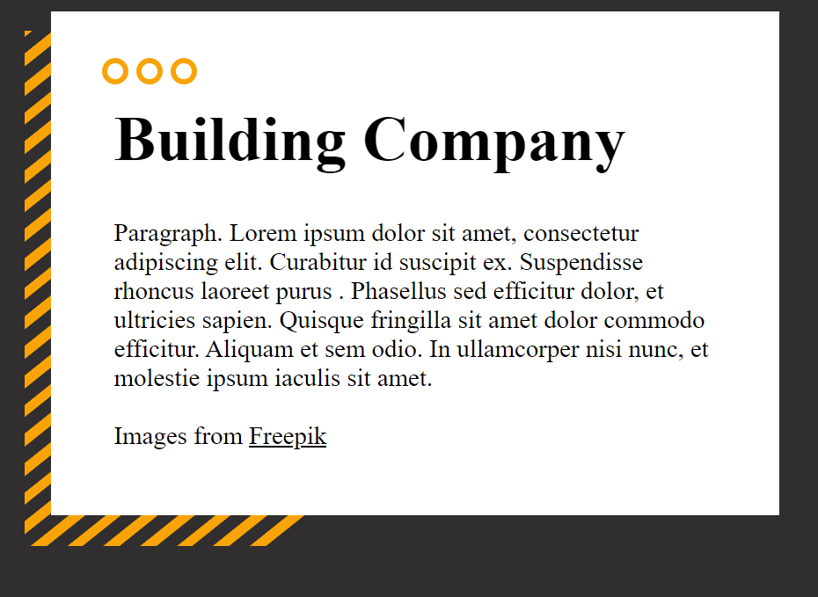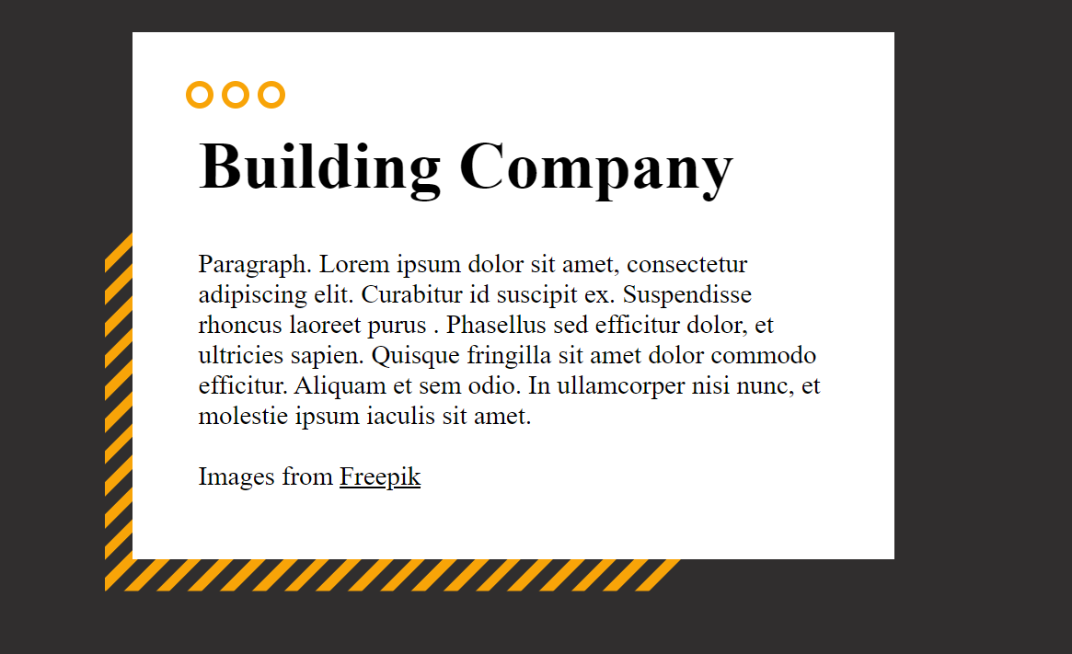

The stripes are positioned absolutely relative to their parent. The **grid** is the actual visible part of the stripes (the yellow stripes) while **stripes** is the transparent container that contains them, and since it is transparent it creates the illusion that these are all a bunch of lines, and not a container-box. To make the effect of the lines being angled, we added a **skew**() effect to the grid inside the **stripes** container, and set the overflow for the container of the grid rows to none, so that the lines would not be visible cutting throught their parent element. This makes the **grid** container inside the **stripes** parent skew, but the transparent parent still remains oriented normally, thus making the illusion complete. On hover, over the child grid element, inside the transparent **stripes container**, we’ve added a translateY() transform property, which makes the stripes move up 300%(completely off screen). But since it is the grid inside the transparent container that translates on the Yaxis, and it has been skewed to a 45degree angle before that, it means that is Y axis it will translate to is actually at 45degrees to the transparent container element that contains the grid.

This makes it seem like all of these lines are moving to the top left. And if the whole container is covered mostly by a card, like in the image above, this creates thhe illusion of the lines moving around the card, as can be demonstrated in the second image, where it appears the lines have crawled up on the edges of the card, and they will keep going up until all of the stripes overflow their transparent container (that has overflow:hidden set), and dissapear from the screen.

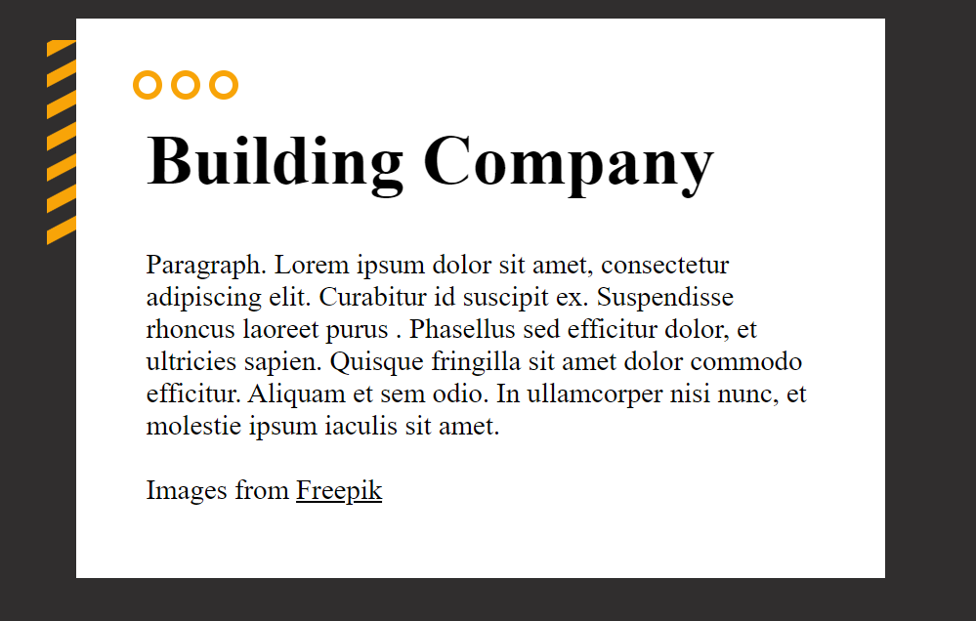

**HTML**

 <div class="stripes">

              <div class="grid">

                <p></p><p></p><p></p><p></p>  <p></p><p></p> <p></p>

                <p></p><p></p><p></p><p></p>  <p></p><p></p> <p></p>

                <p></p><p></p><p></p><p></p>  <p></p><p></p> <p></p>

                <p></p><p></p><p></p><p></p>  <p></p><p></p> <p></p>

                <p></p><p></p><p></p><p></p>  <p></p><p></p> <p></p>

                <p></p><p></p><p></p><p></p>  <p></p><p></p> <p></p>

                <p></p><p></p><p></p><p></p>  <p></p><p></p> <p></p>

                <p></p><p></p><p></p><p></p>  <p></p><p></p> <p></p>

                <p></p><p></p><p></p><p></p>  <p></p><p></p> <p></p>

                <p></p><p></p><p></p><p></p>  <p></p><p></p> <p></p>

<p></p><p></p><p></p><p></p>  <p></p><p></p> <p></p>

              </div>

 </div>

**CSS**

/*stripes underlayer*/

.container .stripes {

  position: absolute;

  top: 60;

  left: 40;

  transform: scale(1.3);

  background: transparent;

  width: 520px;

  height: 320px;

  overflow: hidden;

  z-index: 1; /*index must be smaller than the element it is absolute against*/

}

.container .stripes .grid {

  margin-top: -90px;

  grid-template-rows: 1fr;

  grid-template-columns: 100%;

  transform: skewY(-45deg);

  transition: transform 1s ease-in, opacity 0.5s ease;

}

.container .stripes .grid:hover {

  transform: translateY(-200%);

opacity: 0;

}

.container .stripes .grid p {

  background-color: var(--arch-yellow);

  height: 7.8px;

  width: 100%;

  margin: 5px;

  margin-left: 0px;}

## **Creating a circle-square (square made up of circles)**

*The concept: We want to have a transparent container that has within itself a separate grid element made up out of 7*7 cells. Those cells will each contain a p tag with acharacter of transparent color. In order to align the p tag within a grid cell, it will be assigned a **display: inline-block** property, so as not to take up the entire horizontal space of the grid cell.

To the p tag we will assign a background color, and a border radius so that the background around the invisible <p>character</p> appears circular. To the p-grid elements themselves we will set the **justify-self: center;** property (so that they each align themselves to the center of their grid cell vertically . And to the grid itself, we will set the **align-items: center;** so that all of the items within the grid align horizontally, inside their respective cells.



**HTML**

<div class="circleSquare">

            <div class="grid">

              <p>.</p><p>.</p><p>.</p><p>.</p><p>.</p><p>.</p><p>.</p><p>.</p><p>.</p>

              <p>.</p><p>.</p><p>.</p><p>.</p><p>.</p><p>.</p><p>.</p><p>.</p><p>.</p>

              <p>.</p><p>.</p><p>.</p><p>.</p><p>.</p><p>.</p><p>.</p><p>.</p><p>.</p>

              <p>.</p><p>.</p><p>.</p><p>.</p><p>.</p><p>.</p><p>.</p><p>.</p><p>.</p>

              <p>.</p><p>.</p><p>.</p><p>.</p><p>.</p><p>.</p><p>.</p><p>.</p><p>.</p>

              <p>.</p><p>.</p><p>.</p><p>.</p><p>.</p><p>.</p><p>.</p><p>.</p><p>.</p>

              <p>.</p><p>.</p><p>.</p><p>.</p><p>.</p><p>.</p><p>.</p><p>.</p><p>.</p>

   </div>

 </div>

**CSS**

/*cicleSquare*/

/*transparent square with circles inside its child grid*/

/*Building the square made up of circles*/

.building .container .circleSquare {

  width: 180px;

  height: 180px;

  background: transparent;

  z-index: 10;

  overflow: hidden;

}

.building .container .circleSquare:hover {

  transform: scale(1.2);

  opacity: 0;

}

.building .container .circleSquare .grid {

  grid-template-columns: repeat(7, 1fr);

  grid-auto-columns: 5%;

  grid-template-rows: repeat(7, 0.1fr);

  grid-auto-rows: 5%;

  align-items: center;

  /*hover animation*/

  transition: transform 1s ease-in, opacity 0.5s ease;

}

.building .container .circleSquare .grid p {

  display: inline-block;

  width: 60%;

  height: 60%;

  background-color: var(--arch-yellow);

  border-radius: 50%;

  align-self: center;

  margin: 0;

  color: transparent;

  justify-self: center;

}

## **Keeping our main container elements from stretching over their sections when we zoom out. (the joys of using Max-Width property)**

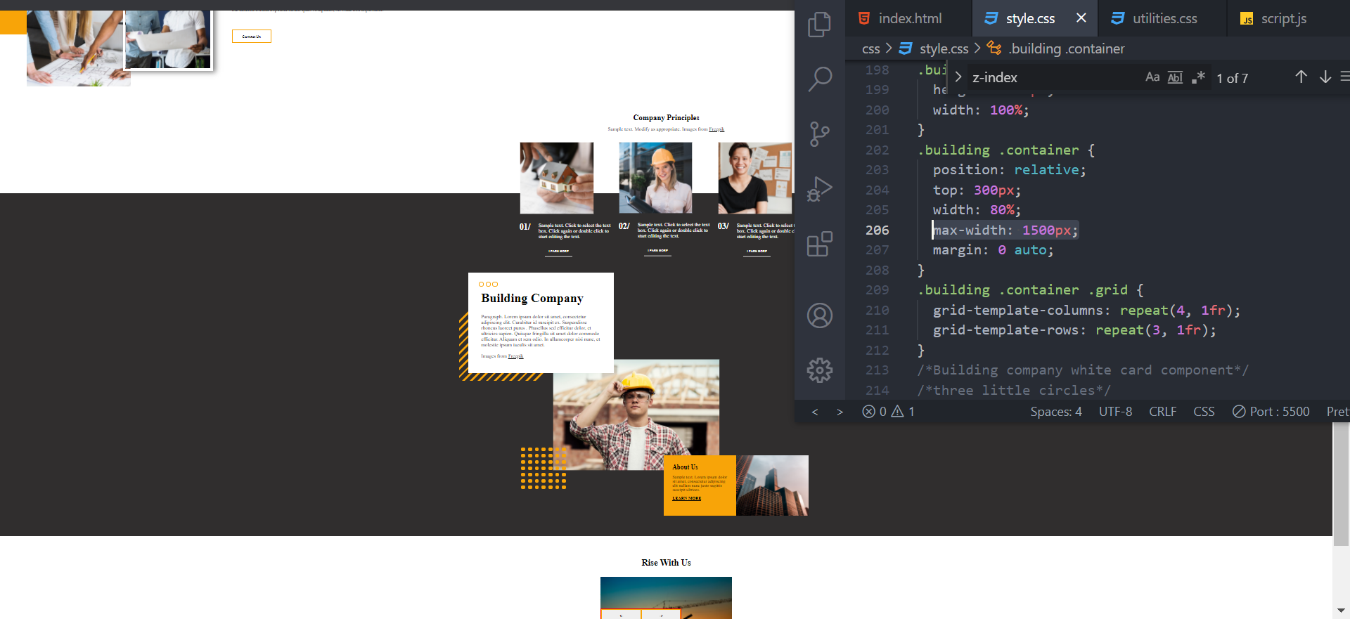

Figure 2Excellent web developing ^___^

When we zoom out, we want our section backgrounds to stretch, over the entire viewport, but what we never want is for our content inside those sections to lose shape, or even worse, somehow get ripped appart by our carefully set-up margins/padding and positioning. One way to effectively combat this, is to set the **max-width** property. This property will override any automatic stretching of our elements by the browser as it expands.

Below we will see how our **Building Company** section gets completely obliterated by zooming out, if we had not previously set a **max-width** property.

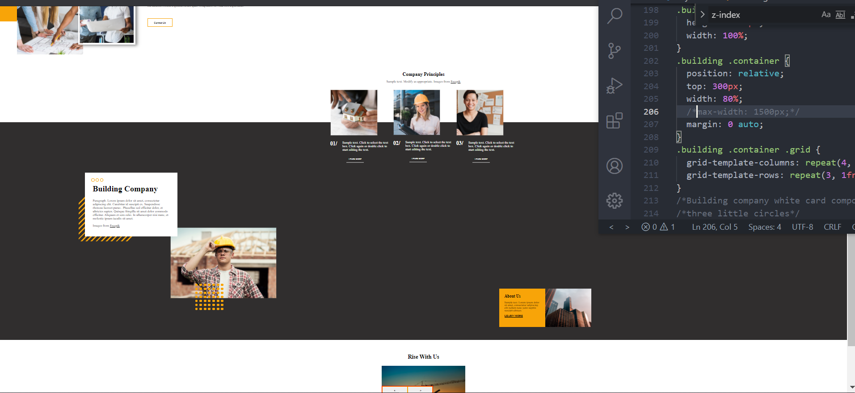

Figure 3Crap web developing!

The image says it all. In the first example the layout is preserved completely, by setting the max-width threshold. In the second example, everything goes just completely awol. **Learn from this mistake, don’t ever make it again!**

### Positioning absolute elements across their relative parent

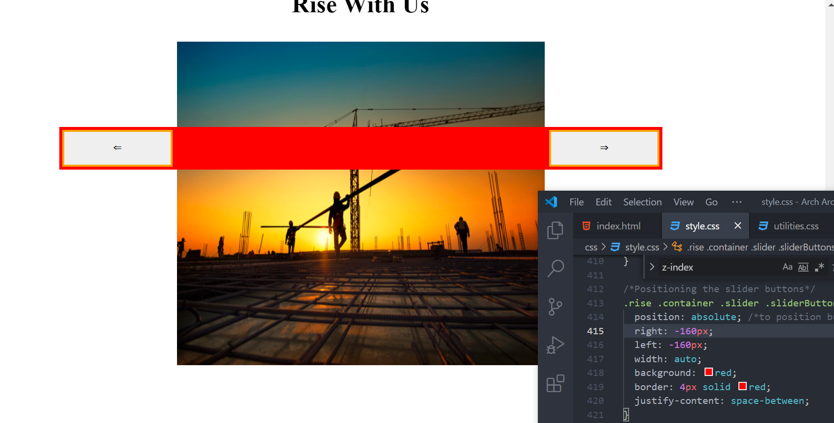

What we see here is a flex-box with two button tags. This flex box is in the same container as the image and the image is as large as the container. What we want to do is have the flex box over the container instead of being at the bottom as the last element.

To do this, we set **position: absolute,** align the top and bottom as necessarry, but the most important part is as follows:

The buttons are originally stuck together like so:

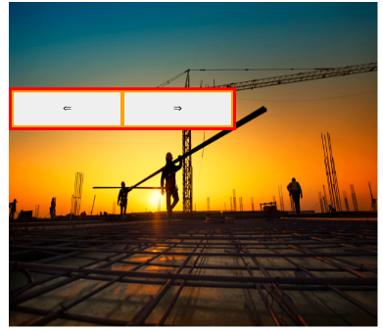Now to make them stretch over their parent element we don’t have to assign them a width. **We can simply tell the element to start the same distance away from the right, as from the left**

 position: absolute; /*to position buttons over the slider*/

  right: -160px;

  left: -160px;

This will make the element stretch over the entire container, and seeing as the numbers are negative, it will actually overflow outside of the container element.

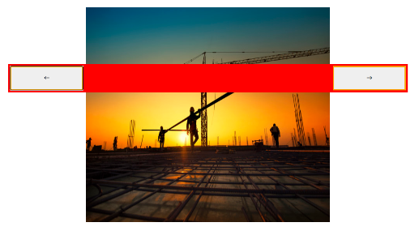Now we can make the background transparent, and even fit a third element inside the flex container, and use it as a sort of watermark over the image (image/slider in this case).

## **Making an absolute container centered over a section made up of more than one container**

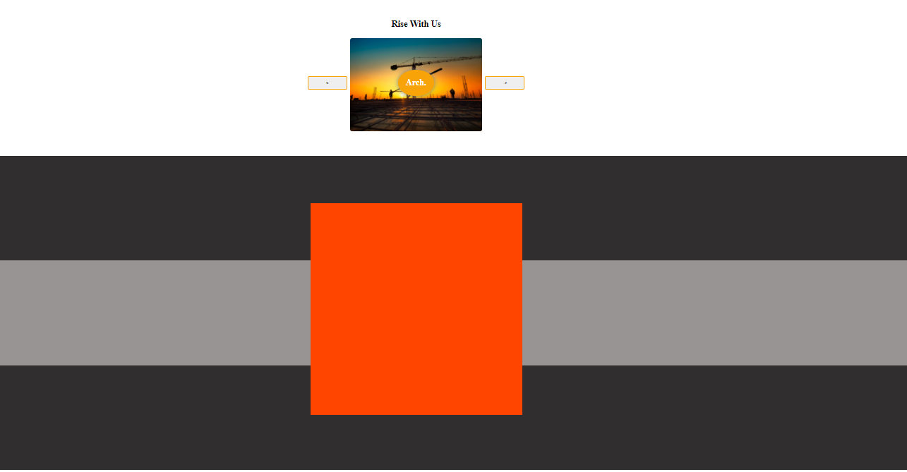

What we have here is a section, that has a background of three colors, made up of three divs.

<section><div1><div2><div3><div4 class= “absoluteRedSquare”></section>

Here is how we’ve made this square center and remain centered (responsive) no matter how much we scroll out or in.

/*####Our Projects section####*/

.ourProjects {

  position: relative; /*so that showcase can be absolute*/

  width: 100%;

  height: 1200px;

}

/*creating our multi colored background*/

.ourProjects > * {

  height: 33%;

}

.ourProjects .showcase {

  position: absolute;

  width: 800px;

  height: 800px;

  margin: 0 auto;

  top: 15%;

  left: 10%;

  right: 10%;

  background: orangered;

  z-index: 15;

}

# Making various shapes with clippy-css (<https://bennettfeely.com/clippy/>)

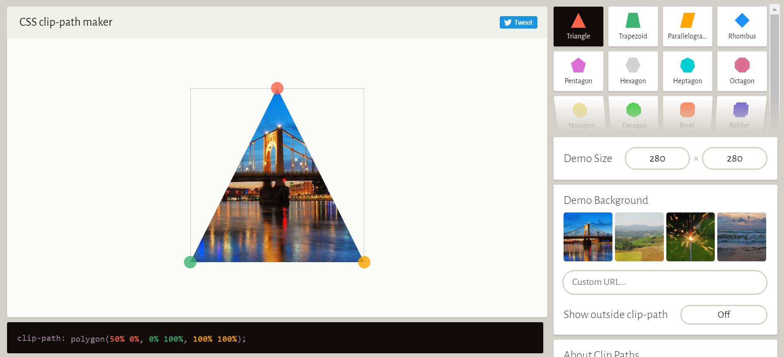

## **Adding Icon-libraries (social media icons, phone, book, heart, like etc…)**

<!-- Add icon library -->  
<link rel="stylesheet" href="https://cdnjs.cloudflare.com/ajax/libs/font-awesome/4.7.0/css/font-awesome.min.css">

<!-- Add font awesome icons -->  
<a href="#" class="fa fa-facebook"></a>  
<a href="#" class="fa fa-twitter"></a>

### **Modifying icon-style for your website in css (best done in the ‘utilities.css’ file)**

/* Style all font awesome icons */  
.fa {  
  padding: 20px;  
  font-size: 30px; /*Font size scales up the icon image*/  
  width: 50px;/*width and height scales up the icon container, not the icon*/  
  text-align: center;  
  text-decoration: none;  
}  
  
/* Add a hover effect if you want */  
.fa:hover {  
  opacity: 0.7;  
}  
  
/* Set a specific color for each brand */  
  
/* Facebook */  
.fa-facebook {  
  background: #3B5998;  
  color: white;  
}

Making images fit their containers

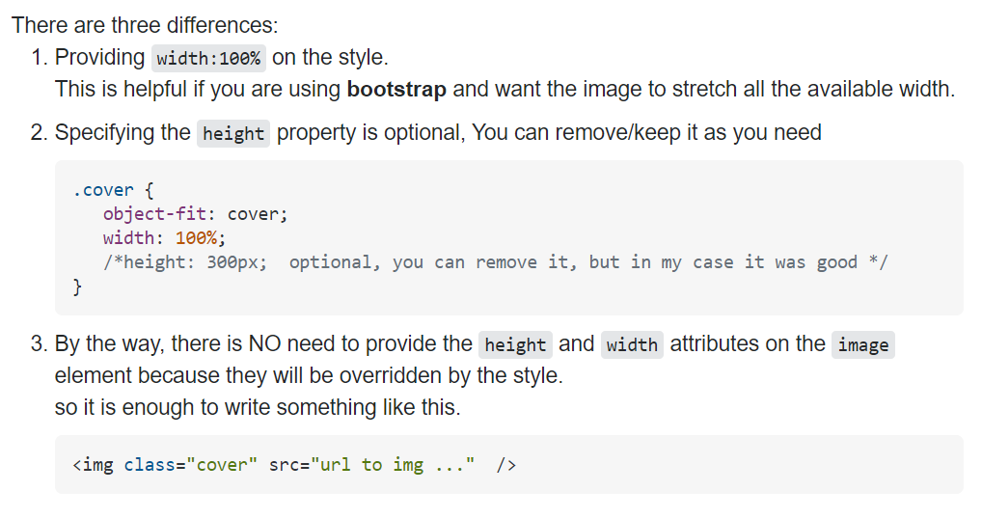

### **Setting up social media icons evenly distributed on the bottom of a container 🡪 FLEX-BOX**

# **Mountain Expedition Club Website (MEC website)**

Inspiration template [Extreme mountain expedition Website Template (nicepage.com)](https://nicepage.com/st/17754/extreme-mountain-expedition-website-template)

# **NATOURS WEBSITE PROJECT**

## (ADVANCED CSS and SASS)

**Note that each and every html element should be given a class name.**

### **The basic way to perform a basic reset using the universal selector**

/*Performing the basic reset note that ideally it selects the pseudo elements

As well as inherit the box-sizing border-box value from the parent element*/

* {

  margin: 0;

  padding: 0;

  box-sizing: border-box;

}

### **The best way to perform a basic reset using the universal selector**

body {

  font-family: "Lato", sans-serif;

  font-weight: 400;

  font-size: 16px;

  line-height: 1.7;

  padding: 3rem; /*padding will not get inherited, it just applies for the body element*/

  box-sizing: bored-box;

}

*,

*::after,

*::before {

  margin: 0;

  padding: 0;

  box-sizing: border-box;

  box-sizing: inherit;

}

### **General css notes part1:**

#### background-position: top/bottom/center;

**Used to define which part of the background gets cropped as the viewport shrinks up/down**

This is the property we use when defining a responsive background image. What it does is define which part of the background **does not get cropped** as the viewport shrinks vertically. **Top(keeps the top of the background from getting cropped**) this means that the bottom part of the background/background image gets cropped. **Bottom(**keeps the bottom part of the background from getting cropped, meaning that the top gets cut as the browser height shrinks **Center** used to keep the center from getting cropped. This means that the center will stay inside the minimum-height range of the background and both the bottom and the top of the image will get cropped leaving the center intact.

Note that browsers can shrink on the Y and X axis, only to a certain point. Using properties like this.

#### Navigating through folders when accessing a link

Background-image: (url(*../images/hero.jpg*);

 ../ -->leave current folder (travel one folder up)

  images/hero.jpg  --> enter the images folder and open hero.jpg file

  */

#### Setting more than one background image

  background-image: linear-gradient(to right, var(--light-green),var(--dark-green)),url(*../images/hero.jpg*);

The first image will be the gradient, while the second image will in fact, be the image at the url

Note that we can specify the direction of the gradient using key words as the first parameter:

**To left;**

**To right;**

**To left top;**

**To right bottom;…etc**

linear-gradient(

      to right bottom,

      var(--light-green),

      var(--dark-green)

    )



Figure 4Example of a gradient moving to the right bottom side

### How to set project-wide font definitions.

body {

  /*all the child elements will inherti from the parent body*/

  font-family: "Lato", sans-serif;

  font-weight: 400;

  font-size: 16px;

  line-height: 1.7;

  color: #777;

  padding: 30px; /*padding will not get inherited, it just applies for the body element*/

}

### How to clip parts of elements using “clip-path.”

#### Making triangles with clip-path:poligon( x y, x y, x y, x y); property

Note that this property accepts areguments that denote the position on the x and y axis (in that order) for each of the four corners of a block. That means that the first (x,y) coordinates correspond to the top left corner of the block, whilte the last (fourth(x,y) coordinates correspond to the bottom left of the block.

They are ordered in a clockwise manner:

Poligon(**Xy(topLeft), xy(toRight), xy(BottomRight), xy(bottomLeft));**

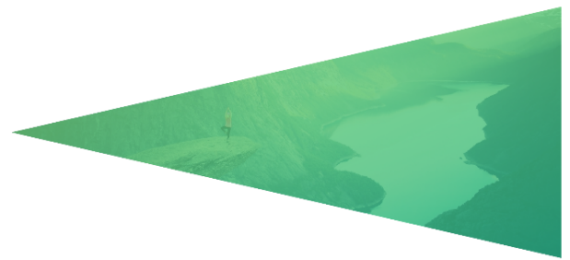Exercise. Make three triangles using the polygon property. To the left, right and top.

Tip of the pyramid is directed to the left.

clip-path: polygon(0 50%, 100% 0, 100% 100%, 0 50%);



Tip of the pyramid is at the top of the box.

clip-path: polygon(50% 0, 50% 0, 100% 100%, 0 100%);

Tip of the pyramid is directed at the bottom.

 clip-path: polygon(0 0, 100% 0, 50% 100%, 50% 100%);

### **The easiest way to center anything with the trasform, top and left properties**

### General Css notes part2.

#### **Scaling images using the (height) property to preserve the original aspect ratio**

.logo {

  height: 35px;

}

width will in this case be controled by the browser, like we set: width:auto

this means that the browser will automatically scale the width/height of the element

in the case of images, if you just set a height or just the width property

the other property will automatically get scaled by the browser, to maintain the

original aspect ratio.

**It is arguably best practice to scale objects, in their dimentions using the height property.**

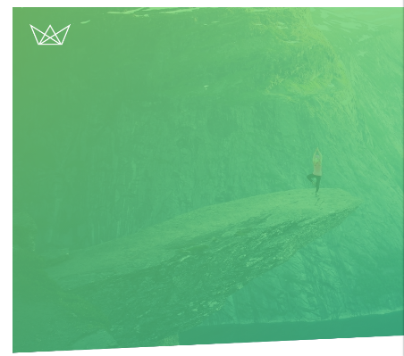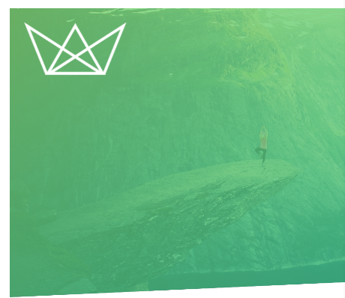

Above we have the example of using three different values for the logo height without defining the width property(letting the browser automatically define width)

.logo {

  height: 50px;

/*height: 100px;*/

/*height: 150px;*/

}

You can notice how the image did not stretch, but the browser automatically scaled the image in order to preserve the aspect ratio. This is important to note when dealing with .jpeg .png images, and redefining their sizes (you don’t have to use scale, and you don’t (nor should you) need to define both widht and height properties in order for the image to scale up or down. Just use the **height** property and leave the width property **undefined** or set to **auto.**

#### **Preventing images from acting like inline elements**

**It is good practice to place images in block level elements or to otherwise give them a (display:block) property, since they are inline elements, and them behaving as an inline element may pose a challenge when aligning them on the webpage**

 <!—Nest every image inside their own container-box🡪

<div class="logo-box">

        <img class="logo" src="images\logo-white.png" alt="Logo" />

      </div>

/*Or apply a general rule for all images */

img{

    display:block;

}

### **Using Position: Absolute and Transform: Translate(x,y) to center-align an object inside its parent element**

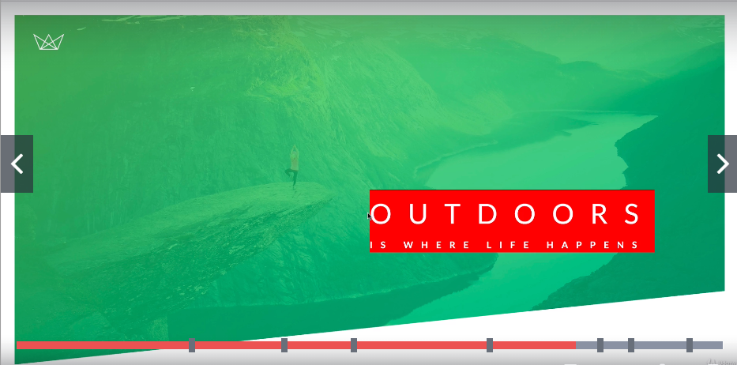

We can see that the top left of the element(**the actual start of our text-box element**) is exactly positioned at the center of its parent (**header**)

.header .text-box {

  position: absolute;

  top: 50%;

  left: 50%;

}

To center align the element now, we would need to move the text-box to the left , around(exactly) 50% of its own width(x-axis) to the left. And we would also need to move the text-box up, exactly 50% of is own height. **Because we want the halfway points of the box (height/width) to be in the exact spot where the top left corner is now**

**To do this we will use the TranslateX(-50%), TranslateY(-50%) functions of the Transform property, or in short translate(-50%, -50%);**



.header .text-box {

  /*center aligning (text-box) on its (header) parent*/

  position: absolute;

  top: 50%;

  left: 50%;

  transform: translate(-50%, -50%);

  /* transform: translateY(-50%), translateX(-50%); */}

## **Creating animations using keyframes**

### **Browser optimization for animation:**

Browsers are optimized to use **opacity** and **transform** properties for **keyframe** animations and **transition** animations, so make sure to use only these two, if you want your website to run well on almost any browser.

### **Triggering keyframe animations on hover. Not just when loading up the page**

.header .logo-box {

  position: absolute;

  top: 40px;

  left: 40px;

  backface-visibility: hidden;

}

.header .logo {

  height: 35px;

}

.header .logo-box:hover {

  cursor: pointer;

  animation: moveInFromRight 2s ease-out;

}

### **Declaring a keyframe animation**

@keyframes *moveInFromRight* {

  0% { 🡪Starting point(the state before the animation happens

    opacity: 0;

    transform: translateX(100%);

  }

  80% {

    transform: translate(-10px); 🡪 Between point of the animation

  }

  100% { 🡪 End point, the state after the animation ends

    transform: translate(0);

  }

}

### Keyframe animation properties

 animation-name: moveInFromRight;

  animation-duration: 1s;

  animation-timing-function: ease-out; /*starts fast and slows down over time*/

  /* animation-iteration-count: 3; //Animation repeats three times */

  /* animation-delay: 3s; //waits 3seconds before starting the animation */

### **Removing the shake from our animations, as the element settles into its original position after finishing the animation**

No one is exactly sure of why the shake happens, but a workaround to fixing it has already been found, non the less.

We simply have to add the following property to the element that is doing the animation, to prevent the shake from getting displayed.

**backface-visibility:hidden;**

This makes the space behind the element(back of the element, heads/tails of a coin) doing the transformation hidden, so that as the transformation happens, whatever is standing in as a placeholder for the element, until the transformation ends, becomes hidden.

The change from the placeholder to the main element getting displayed back to where it was is what is thought to create the shake.

If the placeholder is invisible in the first-place, the shake is invisible too.

**REMEMBER TO ADD THIS PROPERTY ON ALL OBJECTS THAT HAVE ANIMATIONS IMPLEMENTED!!**

## **What pseudo elements and pseudo classes are**

Pseudo classes are special states of elements(selectors in css)

#### **:Link and :visited pseudo classes**

Note that links have one of two primary states(unvisited/visited)

The **:link** [CSS](https://developer.mozilla.org/en-US/docs/Web/CSS) [pseudo-class](https://developer.mozilla.org/en-US/docs/Web/CSS/Pseudo-classes) represents an element that has not yet been visited.

We use this state to style the way we want our links to look when they have not yet been visited

.btn:link {

}

 <a href="#" class="btn btn-white">Discover our tours</a>

We should generally style anchor element buttons, using the :link pseudo class.

In the cases that we wish for both link-states to be styled the same, we would simply use a selector for the element applying both link-states, as follows:

.btn:link,

.btn:visited {

  text-transform: uppercase;

  text-decoration: none;

  padding: 15px 40px;

  display: inline-block;

  /*links are usually inline elements*/

  /*and so, this button would normally be jammed inside the h1 text above it */

}

### **When it a best practice to display elements as inline-blocks:**

#### Always display elements as inline blocks, if you wish to give them padding, width/height, properties

Note that inline block elements are **treated as text**, this meas tht you can center them from the parent container using **text-align:center;** property

**How references work when we have more than one pseudo element transforming an object**

.btn:link,

.btn:visited {

  text-transform: uppercase;

  text-decoration: none;

  padding: 15px 40px;

  display: inline-block;

  /*links are usually inline elements*/

  /*and so, this button would normally be jammed inside the h1 text above it */

}

.btn:hover {

  transform: translateY(-3px);/*related to the initial link state*/

}

.btn:active {

  transform: translateY(-1px);/*related to the initial state(not hover)*/

}

### Animating a button shadow



Figure 5During a click

Figure 6Before a click

We want the shadow to appear smaller(less difused, and more intense as the user clicks on the button, creating the illusion that the element is actually closer to the page

btn:hover {

  transform: translateY(-3px); /*related to the initial link state*/

  box-shadow: 0 10px 20px rgba(0, 0, 0, 0.2); /*offsetX offesetY blur color*/

}

.btn:active {

  transform: translateY(-1px); /*related to the initial state(not hover)*/

  box-shadow: 0 5px 10px rgba(0, 0, 0, 0.2);

}

## Using :before and :after pseudo elements

### Changing the pseudo element on hover of a non-pseudo element

/*styles the ::after element when we hover the .btn element*/

.btn:hover::after {

}

Why does it work this way, well, this basically defines the after element, only after the button is in a hover state: **.btn:hover::after**{…};

## Delayed animations that start with 0(zero) opacity

**animation-fill-mode: backwards;**

Animation can be delayed, so that they would start after a set amount of time (after loading for example).

The problem that can arise is if the animation starts with the opacity of 0(invisible) but, is delayed (4secs, let’s say). Normally this would mean that the object first displays normally for 4seconds, then gets the animation-start opacity of 0. This would make the element dissapear before the animation starts, if the animations @keyframe starts with opacity 0.

One way to work around this problem would be to set the following property value:

**animation-fill-mode: backwards;**

This will give the object the property value set at keyframe{ **0%{opacity:0}** 100%{opacity:1}}

In this case, the object will first appear with the opacity 0, and after a delay of 4 seconds the animation would start and the opacity will begin rising from 0 to 100.

# Header CSS and Style



**HTML**

<!DOCTYPE html>

<html lang="en">

  <head>

    <meta charset="UTF-8" />

    <meta name="viewport" content="width=device-width, initial-scale=1.0" />

    <!--Google fonts-->

    <link

      href="https://fonts.googleapis.com/css?family=Lato:100,300,400,700,900"

      rel="stylesheet"

    />

    <link rel="stylesheet" href="css/icon-font.css" />

    <link rel="stylesheet" href="css\style.css" />

    <link rel="shortcut icon" type="image/png" href="img/favicon.png" />

    <title>Natours | Exciting tours for adventurous people</title>

  </head>

  <body>

    <!--Building the header-->

    <header class="header">

      <!--Since images are inline elements, some may think it is a better practice

        to keep them inside a container(block element)-->

      <div class="logo-box">

        <img class="logo" src="images\logo-white.png" alt="Logo" />

      </div>

      <!--Our main heading thext-->

      <div class="text-box">

        <h1 class="heading-primary">

          <span class="heading-primary-main">Outdoors</span>

          <span class="heading-primary-sub">is where life happens</span>

        </h1>

        <a href="#" class="btn btn-white btn-animated">Discover our tours</a>

      </div>

    </header>

  </body>

</html>

**Style**

/*

COLORS:

Light green: #7ed56f

Medium green: #55c57a

Dark green: #28b485

*/

:root {

  --light-green: #7ed56f;

  --medium-green: #55c57a;

  --dark-green: #28b485;

}

/*Performing the basic reset*/

* {

  margin: 0;

  padding: 0;

  box-sizing: border-box;

}

/*properties related to font are inherited*/

body {

  /*all the child elements will inherti from the parent body*/

  /* font-family: "Lato", sans-serif;*/

  font-weight: 400;

  font-size: 16px;

  line-height: 1.7;

  padding: 30px; /*padding will not get inherited, it just applies for the body element*/

}

/*Animations */

/*this animation moves the element to the left, with a slight sway before stopping*/

@keyframes *moveInFromLeft* {

  0% {

    opacity: 0;

    transform: translateX(

      -100px

    ); /*starts far away to the right from the original position*/

  }

  80% {

    transform: translateX(10px);

    /*continues a bit to the left over the original position*/

  }

  100% {

    opacity: 1;

    transform: translateX(0); /*returns to the original element position*/

  }

}

@keyframes *moveInFromRight* {

  0% {

    opacity: 0;

    transform: translateX(100%);

  }

  80% {

    transform: translate(-10px);

  }

  100% {

    transform: translate(0);

  }

}

@keyframes *moveInFromBottom* {

  0% {

    opacity: 0;

    transform: translateY(100%);

  }

  80% {

    transform: translateY(-10px);

  }

  100% {

    transform: translateY(0);

  }

}

/*####HEADER#####*/

.header {

  /*keep the element height always at 95% of the viewport height*/

  height: 95vh; /*95vh --> 95%vieport-height*/

  background-image: linear-gradient(to right bottom, #7ed56fcd, #28b485c9),

    url(*../images/hero.jpg*);

  background-size: cover; /*fits the element inside the full parent box*/

  background-position: top; /*makes sure the top of the image stays at the top of the viewport*/

  clip-path: polygon(0 0, 100% 0, 100% 90%, 0 100%);

  position: relative;

}

.header .logo-box {

  position: absolute;

  top: 40px;

  left: 40px;

}

.header .logo {

  height: 35px;

}

/*styling our heading*/

/*styling the box that contains our heading*/

.header .text-box {

  /*center aligning (text-box) on its (header) parent*/

  position: absolute;

  top: 40%;

  left: 50%;

  transform: translate(-50%, -50%);

  /* transform: translateY(-50%), translateX(-50%); */

  text-align: center; /*aligns the text and the button to the center of itself*/

}

/*span elements in our h1 heading*/

.heading-primary {

  color: white;

  text-transform: uppercase;

  backface-visibility: hidden;

  margin-bottom: 60px;

}

.header .heading-primary-main {

  /*we display both span elements as blocks*/

  display: block;

  font-size: 60px;

  font-weight: 400;

  letter-spacing: 35px;

  animation-name: moveInFromRight;

  animation-duration: 1s;

  animation-timing-function: ease-out; /*starts fast and slows down over time*/

  /* animation-iteration-count: 3; //Animation repeats three times */

  /* animation-delay: 3s; //waits 3seconds before starting the animation */

}

.header .heading-primary-sub {

  /*which automatically creates a line break between them*/

  display: block;

  font-size: 20px;

  font-weight: 700;

  letter-spacing: 17.4px;

}

/*we always refer to classes that are links with the :link pseudo class*/

/*below we want our normal link state to look the same as our visited state*/

/*meaning: not to change after the link was clicked*/

.btn:link,

.btn:visited {

  text-transform: uppercase;

  text-decoration: none;

  padding: 15px 40px;

  display: inline-block;

  border-radius: 200px;

  transition: all 0.2s;

  position: relative;

}

.btn:hover {

  transform: translateY(-3px); /*related to the initial link state*/

  box-shadow: 0 10px 20px rgba(0, 0, 0, 0.2); /*offsetX offesetY blur color*/

}

.btn:active {

  transform: translateY(-1px); /*related to the initial state(not hover)*/

  box-shadow: 0 5px 10px rgba(0, 0, 0, 0.2);

}

.btn-white {

  background-color: #fff;

  color: #777;

}

.btn::after {

  /*to make the element visible we must define both content and display properties*/

  content: "";

  display: inline-block; /*here we set inline-block in order for it to display just like the button*/

  /*the ::after element is treated like a child of the selector it is implemented on*/

  height: 100%; /*of the .btn*/

  width: 100%; /*of the .btn*/

  border-radius: 200px;

  /*placing the ::after element exactly behind our button*/

  position: absolute;

  top: 0;

  left: 0;

  z-index: -1;

  transition: all 0.4s;

}

.btn-white::after {

  background-color: white;

}

/*styles the after element when we hover the .btn element*/

.btn:hover::after {

  transform: scaleX(1.4) scaleY(1.6); /*here we wanted our element to grow more on the y axis*/

  opacity: 0;

}

.btn-animated {

  animation: moveInFromBottom 0.5s ease-out;

  animation-delay: 0.75s;

  animation-fill-mode: backwards;

}

## **How CSS works Behind the Scene**

### Three pillars of Writing good HTML or CSS (NEVER FORGET THEM!)

#### **1.Responsive Design**

* Fluid layouts
* Media queries
* Responsive images
* Correct units
* Desctop-first vs mobile-first

#### **2.Writing Maintainable and scalable code**

* Clean
* Easy to understand
* Supports future growth
* Is reusable

It is best defined in:

* How we organize our files
* How we name our classes
* How we structure HTML

#### **3.Web performance**

* Less HTTP requests
* Less code
* Compress code
* Using a CSS pre processor like SASS
* Less images
* Compress image

## **What happens to CSS when we load up a webpage?**

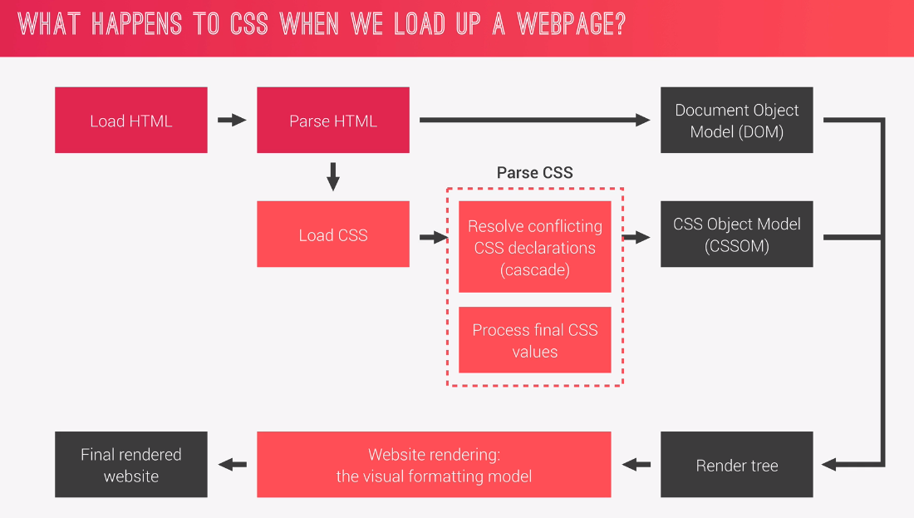

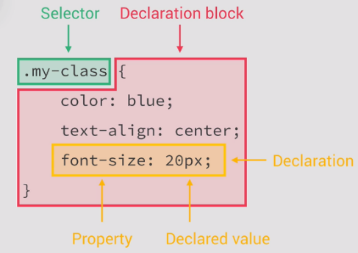**Short note on the terminology we use for writing css, as demonstrated in the image to the left.**

### **The parcing phase**

In the parcing phase, the first step is to resolve the conflicting css declarations, and the second step is to process the css declared values

**The cascade**: The process of coombining different stylesheets and resolving conlicts between different css rules and declarations, when more than one rule applies to a certain element.

**Three types of css are processesed on the browser**

**Author CSS** (the css we as designers/developers write)

**User CSS**(when the user changes browser for example

**User Agent CSS** (the css the browser automatically sets if the author css has not overwritten it)

#### **How the cascade resolvs conflicting css**

**!Importance**

First the declaration with the highest importance is checked. Importance is defined with the css keyword

.box{ color: green; !**important**}

Now User and author can both set this keyword so they are not measured equally, the user set keyword takes precedance over the Author defined keyword

If the keyword is not used in a conflicting statement, all elements, be they user, author or agent, are considered of an **equal importance**. Because of the parcing considers specificity next…

**Specificity**

Inline styles have the highest specificity

1.Inline styles

2.Ids

3.Classes, pseudo-classes, attribute

4.Elements, pseudo-elements

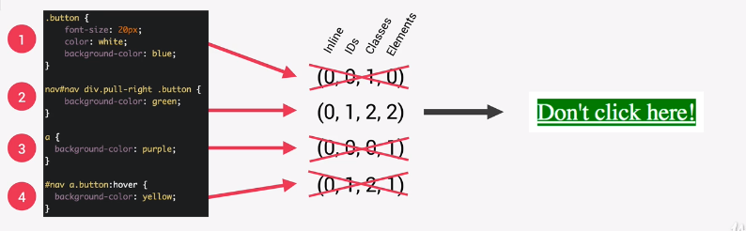

Here we have four conflicting declarations:

Specificity is basically counts how many instances of the following parameters appears for a single css selector statement, counts them and compares the conflicting ones.

The cascade compares these values from left to right. Whichever element, in the column has the highest value wins, and moves on to the next column.

The first column(**Inline)**, has all four zeros (0). All elements pass to the next round. If one element would have been attached as an inline style, it would win and all others would be ignored.

**The second(ID**)column has 0,1,0,1. This means that the second and fourth element tie, and move to the next round, the other two are ignored

**The third (Classes**) column is also a tie 2, 2

The fourth(Elements) column is 2,1, so the second style wins and the background is set to green

**At any point in the cascade an element can win on specificity**

Note that any element that has the highest value in the current column of the cascade, higher than all other conflicting statements, takes precedence, and automatically gets applied, while the others get ignored.

#nav div.pull-right a.button{color:red;}

#nav div.pull-right a.button:**hover**{ color: green;}

Note that pseudo classes count as an added class, and so the declaration with the :hover pseudo class has a higher specificity count, than the one without it. **Remember this**

### **Source-order**

What happens, though when two or more elements tie on specificity?

The last written declaration will in that case overwrite the one written before it.

**If in importance and specificity the declarations tie(are even) only the last written declaration will apply**

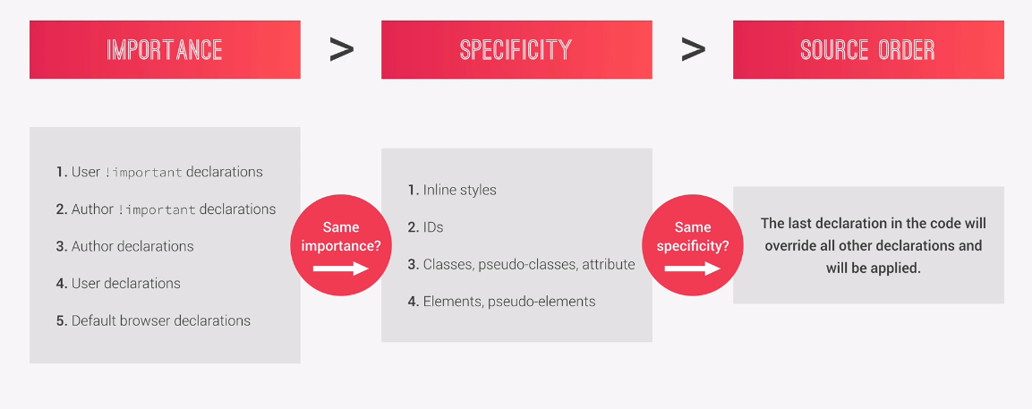

**Summary**

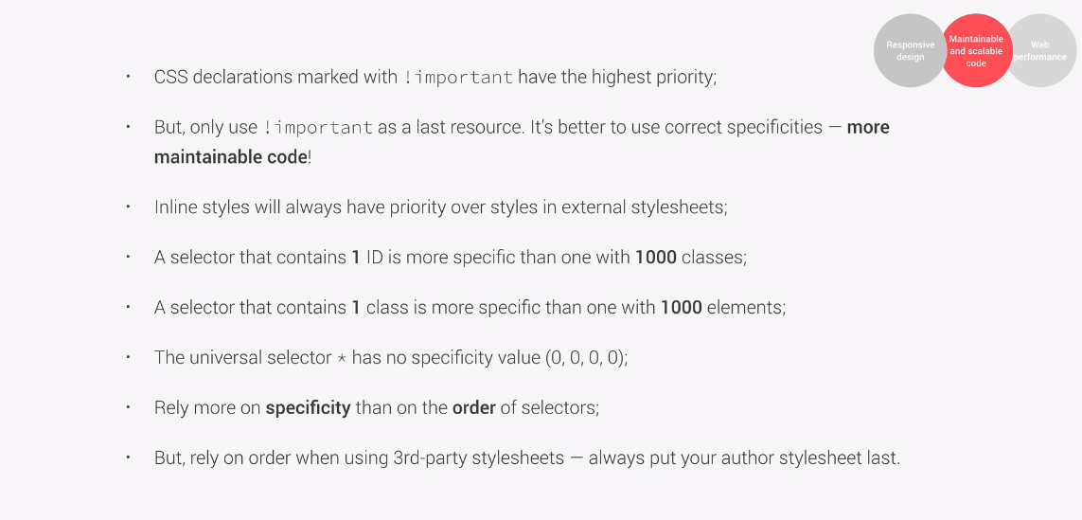

**Summary notes**

If we want to be really specific, we simply need to write a single #id selector, there is no reason to cram up 10 classes one after the other.

Also, if we find ourselves using a bunch of elements in a selector, we are better of (in the same vein) using a single class instead of them.

The fact that the universal selector(*) has no specificity (zero specificity) means that anything we write that conflicts with declarations within a declaration block of an univesal selector, will in fact, overwrite it (take precedence over the universal selector rule)

The idea to rely more on specificity than on order of selectors, means that you want to be able to rearange(top/bottom) your css code, without it actually affecting your css rules. If you rely on order, you are setting yourself up for hell, when cleaning your code.

Only use the !Important keyword as last resort, in case your really, really cannot find and resolve your conflicting css declarations using specificity or at the very least (order) Avoiding the use of order and Importance keeps the code scalable and maintainable, and so it is key that we avoid it, keeping the code as clean as possible.

## Value Processing

All value units(em, rem, vh, fr,%) ultimately get converted to px

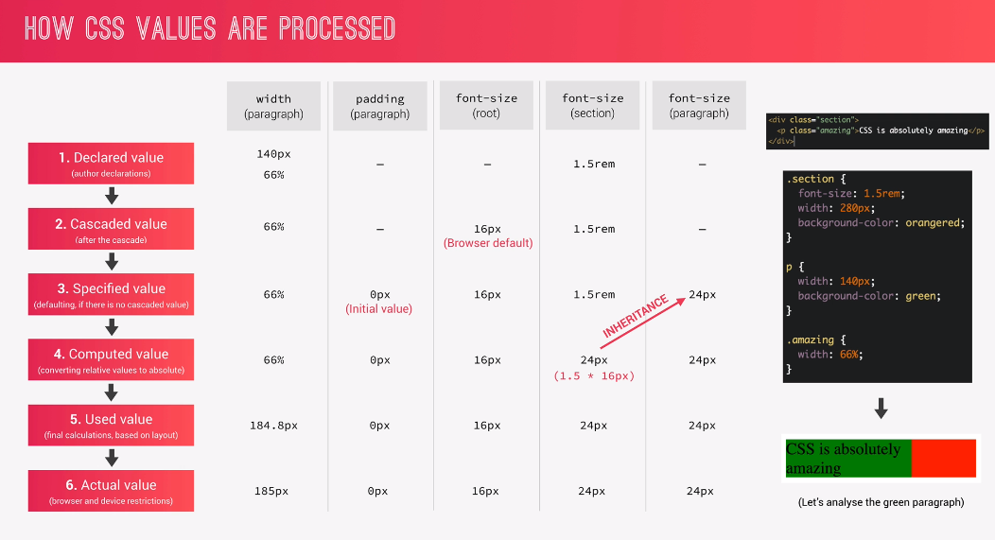

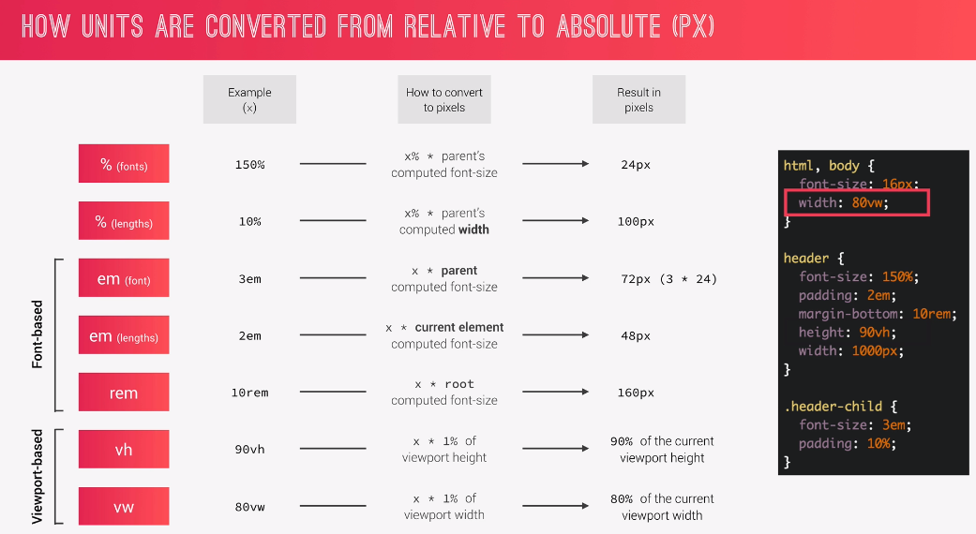

**Summary**

* Each property has an initial value, used if nothing is declared(and if there is no inheritance
* Browsers specify a root font-size for each page(usually 16px); User Agent css does this
* Percentages and relative values are always converted to pixels
* Percentages are measured to their **parent’s font-size** if used to specify **font-size**
* Percentages are measured relative to their parent’s **width!!**, if used to specify hight or width
* Em are measured relative to their **parent** font size, if used to specify font size
* Em are measured relative to the **current** font-size, if used to specify lengths.
* Rem are always measured relative to the **document’s** root font-size
* Vh and vw are simply percentages of viewport’s height and width

## **Inheritance**

* Inheritance passes the values for some specific properties from parets to children –More maintainable code.
* As a rule of thumb, properties related to text are inherited(font-family/size, color,etc…)
* Properties related to size (padding, margin, width, height… ) are not inherited
* The computed value of a property is what gets inherited, **not** the declared value

(Computed value is the actual value of the parent element, for said property, not the value the user/editor wrote in the parent. This means that if the parent has font size: 30%, the declared value is 30%, but it’s child will not inherit 30% (which would in fact mean, 30% of the parent’s 30%, the child inherits the computed(calculated value of the parent property)

So the font size is first calculated 30% of let’s say 100px is 30.333px, which will round to 30px. The child will not inherit the **declared value (font-size:30%)** but the **claculated value(30px)**

* Inheritance of a property only works if no one declares a value for that property.
* The **INHERIT** keyword, forces inheritance on a certain property (width/height, for example, which are not normally inherited).
* The initial keyword resets a property to its initial value.

## Using the REM or Em relative units instead of Pixels

First of all, why would we do this?

Well, the idea is that If everything in our site, scales according to the root, or parent pixel size. We can scale up or down, all of our element sizes, just by changing font sizes.

This effectively means that when scaling down elements, all the proportions remain, and we only have to change the font size, and not add a bunch of custom sizes inside media queries

**Note: The root font size (REM) is actually set in the html tag (html selector)**

html {

  font-size: 10px;

}

This changes the root font size from the initial (default) value of 16px to that of 10px

### Converting pixels into REM

The comon technique for doing this changes the root font size to 10px, so that we can more easily convert the current font sizes to their rem counter parts, by not having to divide them by 16, but by 10, which basically means we simply turn their last px number into decimal.

So the value of **padding:25px;** turns into **padding: 2.5rem;**

## Changing root pixel size with a percentage relative to the root 16px

**Note:** Hard coding px value for the root font size prevents

  users from changing (increasing font size, themselves)

  IF they are low of sight, for example,

  this is why it is a very bad practice for developers

  to hard code their root font sizes using pixels, and instead

  use the good(common) practice, of defining the

  root default value of (16px) with a percentage

  so 100% === 16px

  if we want to set our root to 16px

  we would simply have to divide 10/16 and get 0.625

  that turned into a percentage 0.625*100 = 62.5%

  so font-size: 10px;

  converted to a percentage relative  the default root font-size of 16px

  is font-size: 62.5%

  so font-size: 10px; can be written as font-size: 62.5%

  without ever overwriting the default root font size of 16px

**Best practice:**

html {

  font-size: 62.5%; /*62.5% of ( 100% == 16px) is 10px */

}

## Setting up box-sizing to get inherited by the elements from the body

What we usually do, for box-sizing: border-box; is set it up and define it using the universal selector

*{

box-sizing: border-box;

}

This basically means that all of the elements inside our document have the box-sizing plasticaly set, though not inherited.

For some pluggins, though, it is a better practice to make the elements inherit box-sizing property from the body, instead of having it defined and implemented on all of them using the universal selector. Why this is useful for pluggins( well, quality of life) but, cross that bridge when we get there, no?

Anyhow, how we’re going to do this is simply by doing the following

Remember how only text-properties are implicitly inherited, while the size/sizing properties are not(for convenience sake, you don’t want to have to overwrite an inherited padding of 20px or something like that, for each and every element, always, and their children and so on…)

Well, the thing is, if we want our box-sizing (size-type) property to get inherited, we would have to force inheritance, otherwise the rule will remain local on the element it was declared on.

So, what we smart little css devs will do, is the following:

**body{**

**box-sizing: border-box;**

**}**

**\*{**

**box-sizing: inherit**

**;}**

So now every element on the page will inherit the box sizing value from their global **body** parent.

### Applying global rules for all elements, as well as for the before and after pseudo elements

*,*::after,*::before{ /*selects all the elements,and all before/after pseudo elemnts*/

  margin: 0;

  padding: 0;

  box-sizing: border-box;

  box-sizing: inherit;

}

## The visual Formatting Model

**Definition:** The algorithm that calculates boxes and determines the layout of these boxes, for each element in the render tree, in order to determine the final layout of the page.

* **Dimensions of boxes:** the box model;
* **Box type:** inline, block, inline-block
* **Stacking contexts;**
* Other elements in the render tree;
* Viewport size, dimensions of images, etc…

### **1.The Box Model**

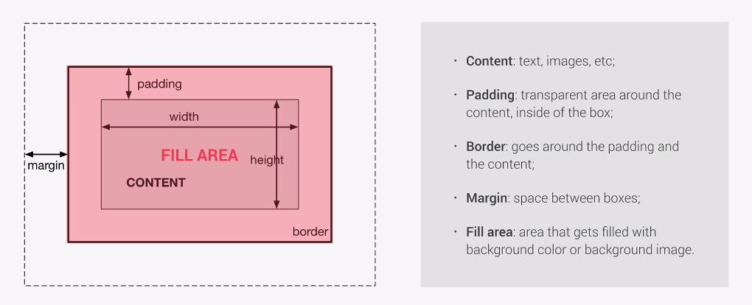

Note how, background-image, background-color property ignores the padding and basically fills the element fully stopping only at its border.

Additional note: padding and margin are completely optional properties, and a box can be created completely without those two.

### **How box-sizing: border-box; actually works**

Note that whenever we add margin or padding to an element, they get added alongside the element height and width. So an element with the widht of 100px and a margin of 20px will actually take up the space of 140px in width. Margin for both left and right side will be of 20px.

Changing the width of the element, will not change the margin or padding set on it, so changing the width of the element to 40px, will still keep the 20px margin on both sides, meaning the element will be 40 +20right+20left px =80px wide.

This is very problematic to leave as is (now that we have a workaround), as we would have to calculate margins, padding and the width summing them up, to get the total box width/height, not to mention changing all three properties were we to want to scale up or down the whole element (without changing the root: font size, if we are using rem units of measure.

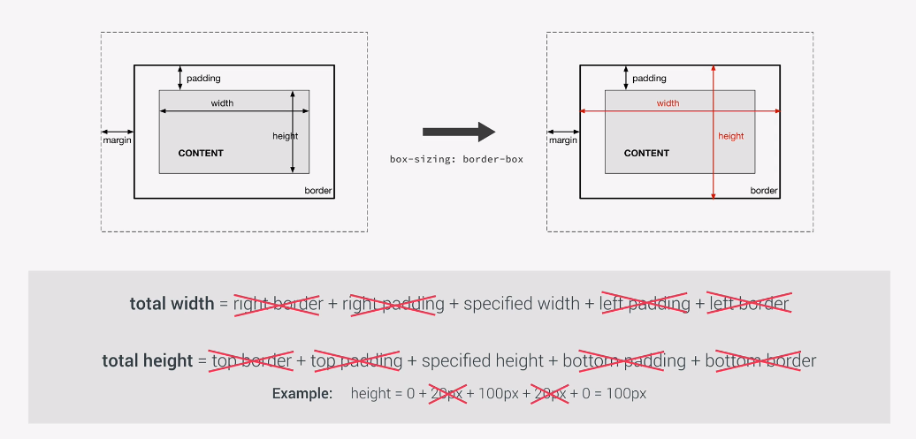

Padding ,border, and margin is not calculated in total width/height. So when we apply a new border or margin, it calculates the new **calculated height** by detracting the border,margin or padding from the initial height/width.

Then it calculates the new **total height/width** by adding up the border/padding/margin to the **calculated height/width**.

**EXAMPLE:**

If the width of an element is 100px, and we add a 10px padding, normally these two values would be summed up together 100px + 10px + 10px = 120px width

But with box-sizing the following happens.

**Initial state:** initial-width = 100px

**Adding margins:** calculated-width = 100px– 10px – 10px = 80px

**Total width** (width + margins) calculated-width + margins = 80px + 10px + 10px = 100px

Note how: **calculated-width(100px) == initial-width(100px) This is** *box-sizing: border-box*

## **Box-Types: inline, block level and Inline-block**

Note that (display:flex, display: list-item, display: table) elements are all block level elements, it is their children that behave in the flex, list-item, table box type

**Block** level elements take up an entire width of the line they are placed in.

**Inline** level elements, only take up as much space as the content inside them requires, the restrictions of these elements lie in the fact that they are distributed over a line, meaning that they cannot cause line breaks, and also cannot have a height exceeding the height of their content, and the margin and padding applied to an inline element, only applies to the horizontal space(left and right) and ignores the vertical space (top/bottom). This has some serious limitations, as you might guess

**Inline-block:** Enter, this box type, basically what it is, is an inline element outside, that behaves like a block level element inside (has the full capacity to have it’s size, padding and margins defined in the horizontal as well as vertical Y axis, plane. Also, just like an inline element, they cannot cause any line breaks, and only occupy the space of its content area, which, unlike line-level elements, includes padding and margins on the vertical axis.

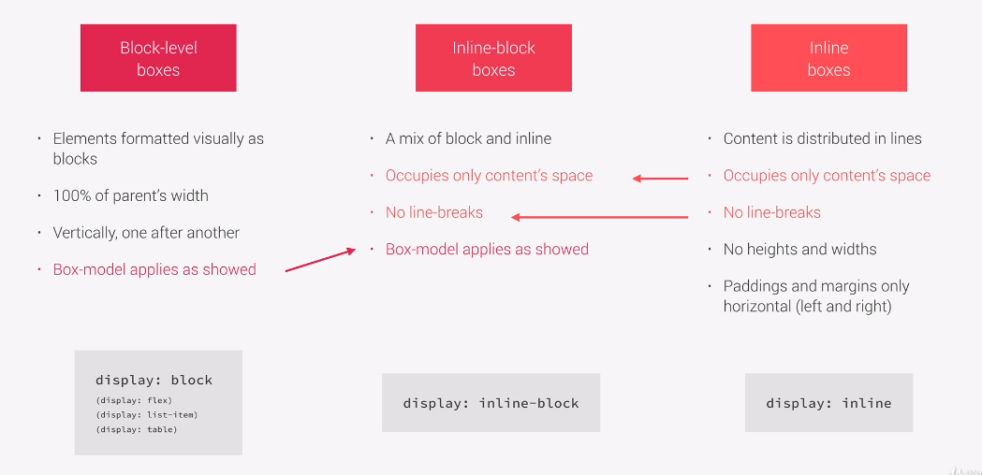

## Positioning Schemes

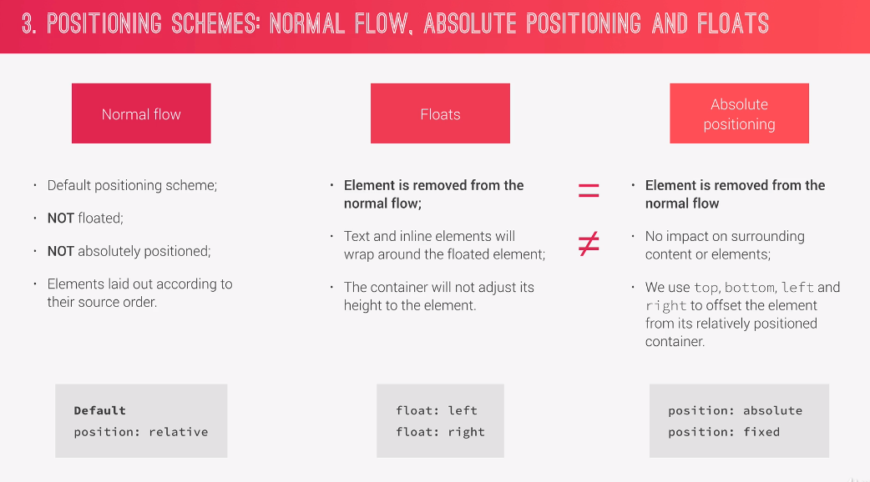

## Stacking contexts

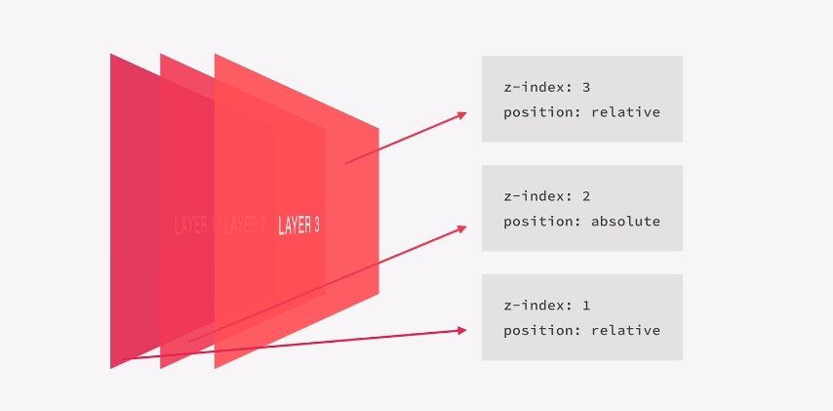

While z-index is the most well known way to create a new stacking context, remember that opacity, and transform properties create stacking contexts of their own. This is why sometimes, even after setting a z-index of an element to over 9000, it may still appear behind its lower power level goku-analogue.

## **THINK-BUILD-ARCHITECHT MINDSET**

### **(HOW TO BUILD GOOD CSS/HTML ARCHITECTURE**

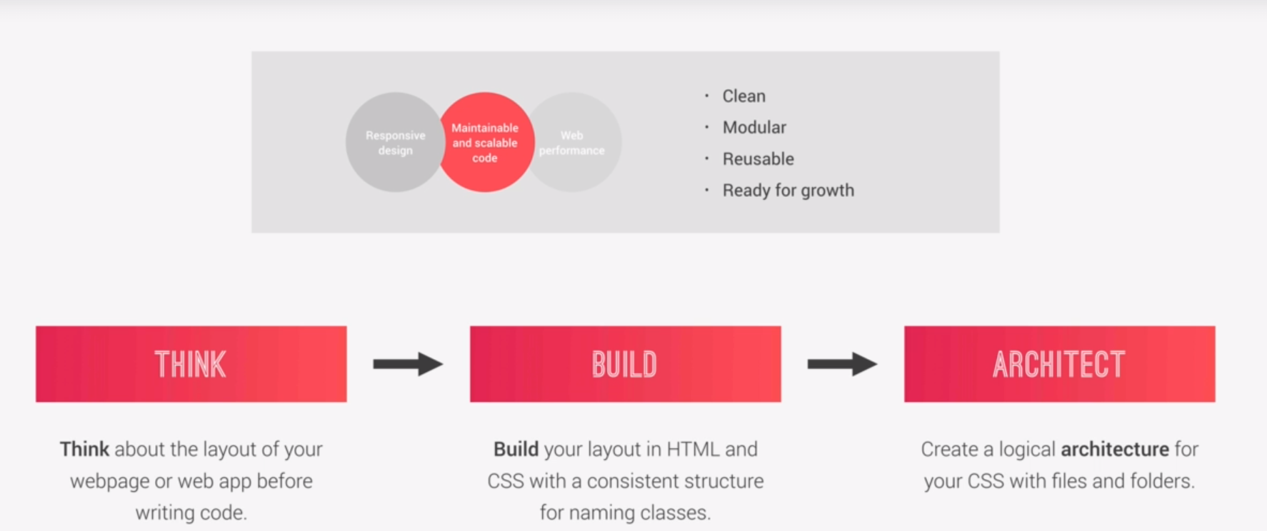

### **Think:**

#### Component driven design

* Create content in **modular building blocks** that make up interfaces;(interface here would be something like a collection of components held together by the overal layout of the page
* **Re-usable** across a project, and different projects
* **Independent,** allowing us to use them anywhere on the page(this means that the components should not be dependant on their parent elements)

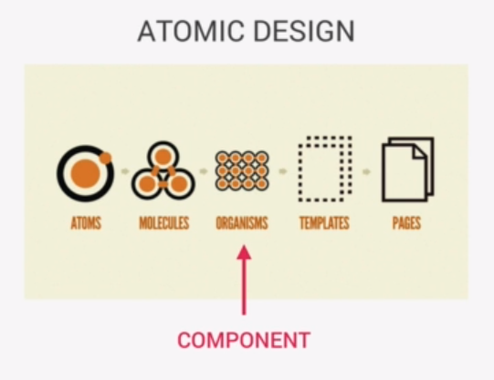**The logic outlined above is very similar to the ATOMIC DESIGN principles.**

## **Build**

#### BEM

* (**B**lock **E**lement **M**odifier)
* **BLOCK** is a standalone component that is meaningful on its own (example, a section)
* **ELEMENT** is a part of the block(ex section/header/footer) and has no meaning on it’s own
* **MODIFIER** used to create a different version of a block or element(a more specific version)

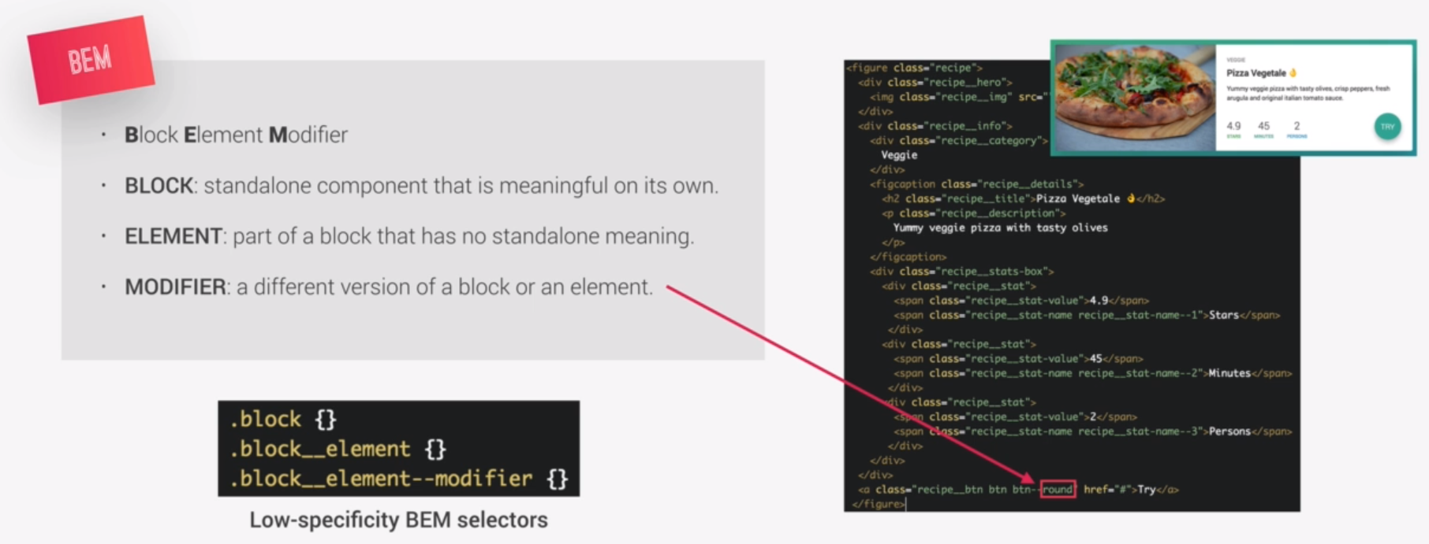

Notice how many times the word recipe is used inside the code. That is the idea, this whole block corresponds to the recipe logical whole. And everything within it is an element that belongs to the recipe block, or a modifier of the block or the element. This means that just by looking at the code, it is incredibly clear which part of the webpage the code belongs to, so we don’t have to fiddle around with the css or html markup to figure out which element is which, as everything is lexically laid out for us.

Some people say this way of writing html is ugly, and takes too much time, but personally for me and for the creator of the materials I’m using here, the more readable the code, the better.

Hacking-samurai….Go! >.<

## **Architect CSS**

### The 7-1 PATTERN

7 different folders for partial SASS(css pre-processor) files, and 1 main SASS File to import all other files into a compiled CSS stylesheet

**THE 7 FOLDERS**

* **Base**
* **Components**
* **Layout**
* **Pages**
* **Themes**
* **Abstracts**
* **Vendors**

## Using BEM in practice

  <body>

    <!--Building the header-->

    <header class="header">

      <!--Since images are inline elements, some may think it is a better practice

        to keep them inside a container(block element)-->

      <div class="header__logo-box">

        <img class="header__logo" src="images\logo-white.png" alt="Logo" />

      </div>

      <!--Our main heading thext-->

      <div class="header__text-box">

        <h1 class="heading-primary">

          <span class="heading-primary--main">Outdoors</span>

          <span class="heading-primary--sub">is where life happens</span>

        </h1>

        <a href="#" class="btn btn--white btn--animated">Discover our tours</a>

      </div>

    </header>

    <!--We can notice that in the BEM notation we have the folowing:

    BLOCKS(logical independant wholes): "header", "heading-primary"."btn"

    ELEMENTS(elements that are logically dependant on their blocks):

    "header__logo","header__logo-box" "heading-primary__text-box"

     MODIFIERS(a more specific version of a block or element):

    "heading-primary--main", "heading-primary--sub"(specific versions of a block)

    "btn--white", "btn--animated" (also specific versions of a block)

    Remember that elements are denoted with double underscore (__)

    while modifiers are denoted with a double dash(--)

    -->

  </body>

# **SASS**

Sass is a css preprocessor, an extension of CSS that adds power and elegance to the basic language.

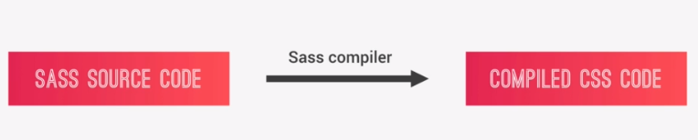

**Main SASS features:**

* **Variables: for reusable values such as colors, font-sizes, spacing, etc;**
* **Nestin: to nest selectors inside of one another, allowing us to write less code**
* **Operators: for mathematical operations right inside of CSS**
* **Partials and Imports: to write CSS in diferent files and importing them all into one single file**
* **Mixins: to write reusable pieces of CSS code;**
* **Functions: similar to mixins; with the difference that they produce a value that can be used**
* **Extends: to make different selectors inherit declarations that are common to all of them**
* **Control Directives: for writing complex code using conditionals and loops(not covered in the course I’m taking)**

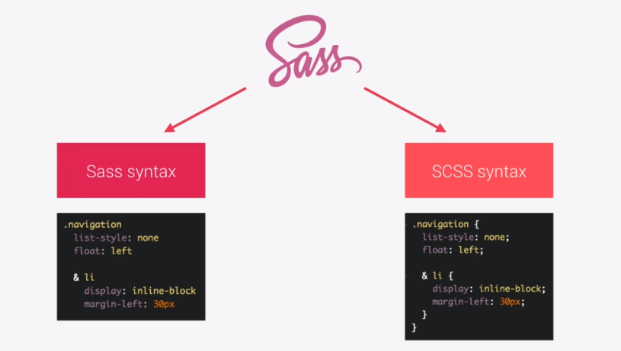There are two ways of writing SASS, one is the original tab-sensitive way, called the **Sass syntax**, and then there is the other way, that more closely preserves the look and feel of the original CSS, called the (SassyCSS ) or the **SCSS syntax** for short.

SCSS is what I’ve chosen to use, as it more closely resembles the CSS we’ve gotten used to in the script, so in that sense, more spillover can only be a good thing, right?

Awesome! :) Keep at it, CSS hacker, game on, and let’s move on to the next chapter ^^

## Learning to write SCSS syntax

Basic HTML below:

<nav>

<ul class="navigation">

<li><a href="#"></a>About us</li>

<li><a href="#"></a>Pricing</li>

<li><a href="#"></a>Contact</li>

</ul>

<div class="button">

<a href="#" class="btn-main">Sign up</a>

<a href="#" class="btn-hot">Get a quote</a>

</div>

</nav>

body{

// box-sizing:border-box;

}

*{

margin:0;

padding:0;

// box-sizing:inherit;

}

$color-primary:#f9ed69;//yellow color

$color-secondary:#f08a5d;//orange

$color-tertiary:#b83b5e;//pink

nav{

margin:30px;

background-color:$color-primary;

}

.navigation{

list-style:none;

//below is a nested selector

//same as writing: **.navigation .li{…}** Also note that there is no limit to the amount of nesting

li{

}

}

### **How the ampersand(&) works in SASS nested selectors**

What it denotes is the selector path up until the point where it has been evoked (similar to “this” keyword but not exactly the same)

If we were to write a selector: **.navigation .li:first-child{}** the ampersand can be used instead of **.navigation .li**

So we would get the following **&:first-child{…}** and it would be exactly the same

If we were not to right & and just write **first-child{..}** what would happen is, it would work as if we wrote **li :first-child{…}**  notice the space between the elements

**.navigation{**

**list-style:none;**

**li{**

**display:inline-block;**

**margin-left:30px;**

**&:first-child{**

**}**

**}**

**}**

The above would work the same if we wrote

**.navigation{**

**list-style:none;**

**li{**

**display:inline-block;**

**margin-left:30px;**

**.navigation li:first-child{**

**}**

**}**

**}**

Hope that this demonstrates how & represents the selector path up until that point in the nesting.

### **Clearfix class used to fix the collapsing of float-parent element**

Using the clear-fix class to fix a collapse within a parent element, if one of its child elements are floated

**<ul class=”clearfix”>**

**<li class=”float”></li>**

**<ul/>**

Imagine that the <li> element floated up, and now the ul parent has no content inside it, meaning that it will collapse (get squashed vertically) since there is no content in it to support its height.

A workaround that would be to create a clearfix class that removes this **squashing** effect and asign it to the parent element, of the element we are floating

**.clearfix::after{**

**content: “”;**

**clear:both;**

**display:table;**

**}**

**.float{**

**float:left;**

**}**

**RANDOM NOTE:**

**Remember that display:inline-block makes the compilter treat the element as text, this means that links <a> set up as inline-blocks, can be centered on their parent container using text-align:center;**

**Exercise:** Try to find each of the nested SCSS selectors, and next to them write out how those nested selectors would have to be specified (writen out) in standard (compiled) CSS

**Solution part1**

*{

margin:0;

padding:0;

}

$color-primary:#f9ed69;//yellow color

$color-secondary:#f08a5d;//orange

$color-tertiary:#b83b5e;//pink

$color-text-dark: #3333;

$width-button:150px;

$color-text-light: #eee;

nav{

margin:30px;

background-color:$color-primary;

&::after{ //as if we wrote nav::after{…}

content:"";

clear:both;

display:table;

}

}

.navigation{

list-style:none;

//bellow is a nested selector

//same as writing: .navigation .li{}

li{ //as if we wrote: .navigation .li{…}

display:inline-block;

margin-left:30px;

&:first-child{ //as if we wrote: .navigation .li:first-child{…}

margin:0;

}

a:link{ //as if we wrote: .navigation .li:link{…}

text-decoration:none;

text-transform:uppercase;

color:$color-text-dark;

}

}

}

**Solution part 2**

.buttons{

float:right;

}

.btn-main:link,

.btn-hot:link{

padding: 10px;

display:inline-block;

text-align:center;

border-radius:100px;

text-decoration:none;

text-transform:uppercase;

width: $width-button;

color:$color-text-light;

}

.btn-main{

&:link{ //as if we wrote: .btn-main:link{…};

//a SCSS function darken(color, darkening%);

background-color: darken($color-secondary,15%);

}

&:hover{//as if we wrote: .btn-main:hover

backround-color:lighten($color-tertiary,10%);

}

}

## SAAS Mixin

It is basically a structure that contains an entire slew of css rule declarations. It contains the css parameters and their values, like an object would, but it acts more like a function.

Once we create it, we simply need to

@mixin clearfix{

&::after{ //as if we wrote nav::after{…}

content:"";

clear:both;

display:table;

}

nav{

margin:30px;

background-color:$color-primary;

@include clearfix; //it is as if we wrote the entire mix-in code body(selector and rules) here

}

}

The **clearfix Mixin** is now reusable anywhere on the page

## **Accepting arguments inside MIXINS**

SCSS vriable declaration: **$color-text-light = #eee;**

Declaration:

@mixin style-link-text($color){

text-decoration:none;

text-transform:uppercase;

color:$color;

}

Call(evokation) of a Mixin with an argument

a:link{

@include style-link-text($color-text-light);

}

### **Writing a function in SCSS**

@function divide($a, $b){

@return $a / $b;

}

Calling the function

//Note that we multiply by 1px to turn the function output into a px value, otherwise it would not work as it would output

//just the number without a unit of measure attached to it

Nav{

Margin: divide(60,2) * 1px;

Background-color:$color-primary;

}

### **SCSS EXTENDS**

While a mixin copies the body declaration to a selector,

The css Extends copies a selector of a rule to the EXTEND declaration

So in other words you have an extend declaration

**%btn-placeholder{… rules for all buttons}**

And you want all of the various button selectors (for the specific and modified button types you have in your website) included in the selector, instead of writing a bunch of selectors like follows:

**.btnCool, .btnHot, .btnCold, .btnAwesome{….rules for all buttons}**

You can write a single selector, an **xtends** selector, and apply it to all the various buttons whose’ selector you want to take place inside the placeholder

So the following happens

.btnCool{

@xtend btn-placeholder

}

.btnAwesome{

@xtend btn-placeholder

}

.btnHotl{

@xtend btn-placeholder

}

Is the same as if we wrote

.btnCool, .btnAwesome, btnHot{…rules for all buttons} 🡨 🡪%btn-placeholder{…rules for all buttons}

Our xtends is a place where we redirect all of the selectors from the various css declaration boxes.

**Xtends should only be used to extend related elements together. (button related extend should only be used on buttons and nothing else) as a best practice.**

**It works basically like implementing an interface, or extending one class with another, but don’t take my word on it, I am seriously iffy on the details at this moment in time, its 3:24am and I’m more than ready to call it a day.**

## Using the Command Line

The fundamental aspect of the command line is that we are **always in a folder**

Type **dir** 🡪 to see all the files in the current directory(dir = directory for short)

Move to a new directory type: **cd Desktop(**currentdirectory Directory-name)

Returning to the root directory

You can always travel back ie(up through the directories) from where you came by typing current directory + spaceBar + 2dots, each time you type and execute the command, you will move up by one level, imagine as if you have a loong slash directory link:

C :\\users\\username\\programfiles\\movies\\favorites\\marvel

Each time you type:( **cd .. )** you will have one directory less in your link (you’l move back to the parent folder) so the first time (cd ..) C :\\users\\username\\programfiles\\movies\\favorites the second time: C :\\users\\username\\programfiles\\movies, third:

C :\\users\\username\\programfiles\\movies,

Fourth: C :\\users\\username\\programfiles,

fifth: C :\\users\\username 🡪 And so on, until you return to the root directory

In windows the root (starting) directory is usually(C:\\users\\username)

**Creating files inside a folder**

Command: **mkdir newDirectoryName**

### Copying a file to the parent folder

**(..)** always means move to the parent folder

Command: **copy fileName ..**

### Moving files

Command: **move fileName ..**

Moving two parent directories up, command: **move fileName ..\..** three (..\..\..) etc…

## Deleting files

Command: **del fileName**

Yeah, that’s it. Note that this completely removes the file, and doesn’t transport it to the trash bin, so be very juditious in its use.

## Installing SASSz

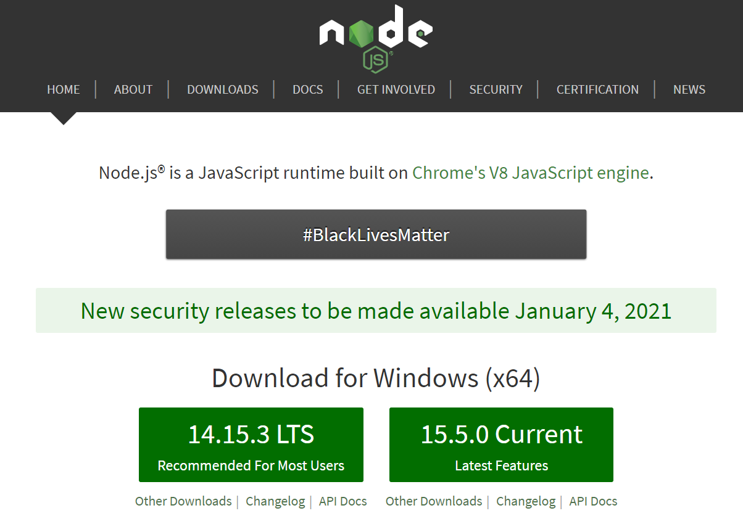

1.Download and instal node.js on your computer

2.In the windows command prompt, go to the directory of your project, and initialize the npm package by writing the following command:

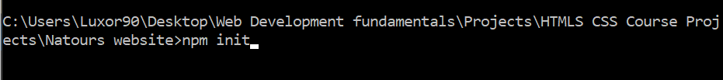

3.Next install sass and save it as a development dependency in our package.json file with the command(--save-dev). This mode of saving means that we are using SASS as a development tool that will help us build our project.



The reason why we want to save sass in our package.json file is, so that we could share our project without having to share the HUUUGE **node.module** folder.

So we only have to send our main project files (html, css, js) with the .json files

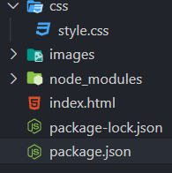and not send the **node_modules** folder.

With .json files someone else who gets our project, only needs to enter the project directory in the command prompt and run (npm install), and the computer will find the required .json files from the project and get all the required dependancies to run and compile SASS locally.

## Writing cass Locally

If we want to use the bracketed SCSS syntax, when creating our main sass file, we would give it the extention **main.scss**

### Converting valid CSS to SCSS

**Note:** valid css is also valid scss, though it does not work the other way around (naturally as you cannot put a code that needs to be preprocessed where processed code normally goes, and preprocessing is what SASS does, babe)

This means that we can literally copy working css into our scss file, and it will run no problem. That is why the go to conversion extention will be .sscss and not .sass

#### Sass variables inside css-function-like constructs

 rgba($color-primary-light, 0,8)

Only sass code accepts a variable name in place of a color (where a color is one of multiple arguments)

## Enabling css processing by SASS

Note that installing SASS and creating a directory and .scss file does not mean that the sass pre-processor actually processes any css code that is writenn in the **.scss** file. For SASS to actually work you have to write a script in the local **package.json** file of the project folder

### **Writing a script that enables SASS to run and output processed css**

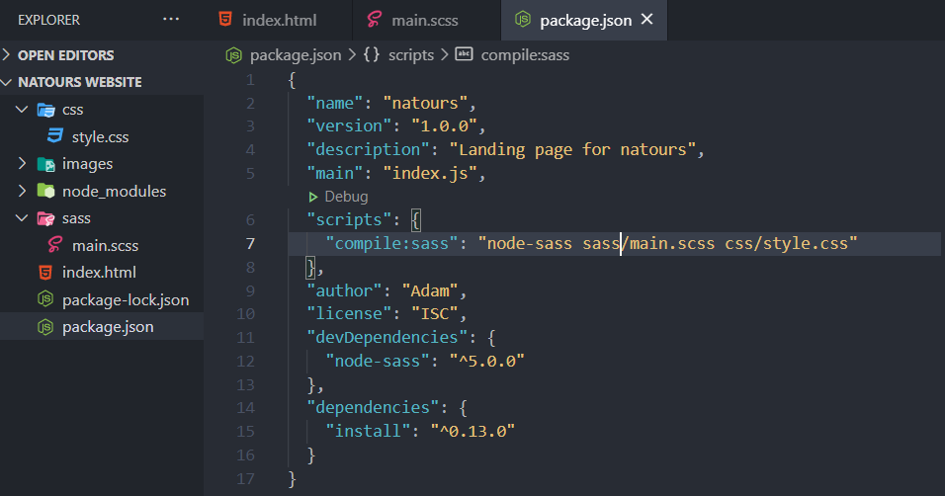

The script itself:

"scripts": {

    //Note that comments are not permmited in json files

    //Command: "package-name inputFileDirectory outputFileDirectory"

    "compile:sass": "node-sass main.scss css/style.css"

  },

1.Name of the package(node-sass-)

2.inputFileDirectory(the location of our **.scss** file)

3.OutputFileDirectory(the location of our base **.css** file, where the processed SASS files should go)

4.Run the script in the command prompt itself with the following:

Command: **run script scrip_tName (“**compile:sass” in our case)

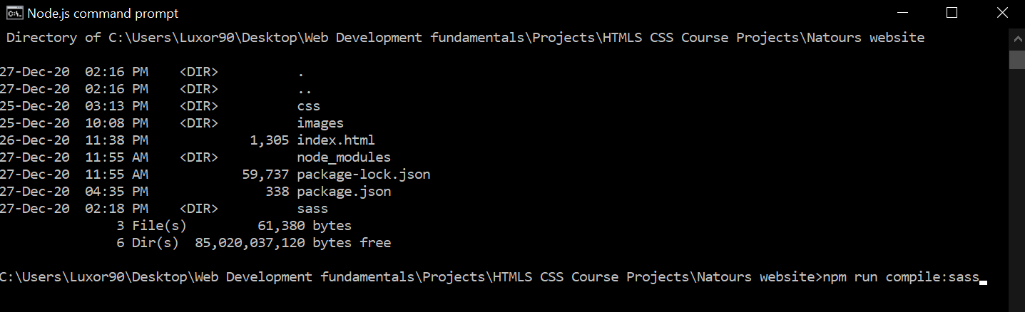

If successful, you’ll get the following console log:



Double check to see if the output css file is in fact inside your project directory (the place where you stored the css file you wanted to use for your project)

--Excuse the fact that my directory is pretty crazy nested inside a bunch of files. ( I was woefuly underprepared to exprect it to matter when setting up the project, initially) From now on, all active projects stay on the desktop. **Note** that if you change the computer, and transfer the project files, it doesn’t matter, you will always first enter the desired project directory from the command prompt, before running the script. So each time your run the script, the exact css file location will be searched for locally, from the directory where you executed the script inside the command prompt. (in simple: it doesn’t matter where you put the project folder, just remember to enter the project folder from the command prompt, whenever you execute a script from from the .json file within the project folder)

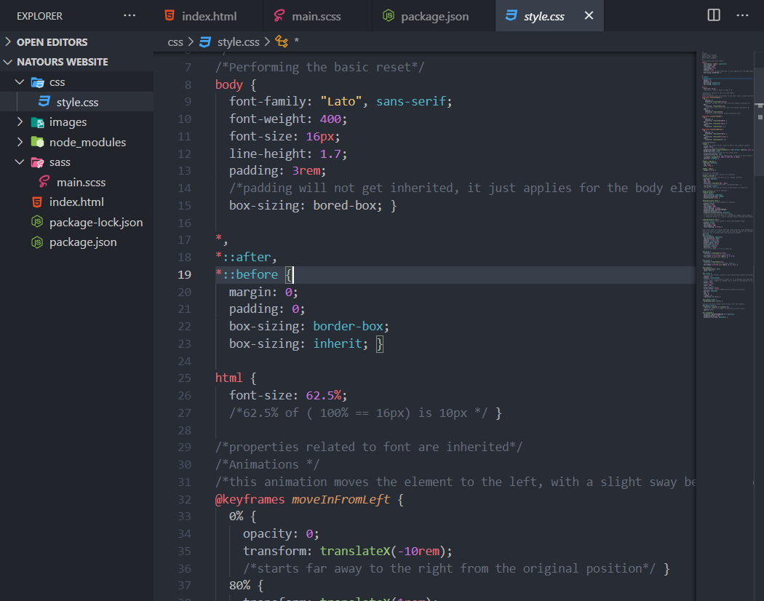

**Note that the browser never learns that you are using SASS, because it only ever sees the css output of the SASS pre-processor.**

**SASS NEED TO KNOW** You write sass code in the **.scss or .sass** file, it gets processed into regular css code and passed to the regular **.css** file. In that css file, when we run the browser, the css gets compiled alongside the html, and voila you’ve got your website ^^

**To check if your sass is processing properly, look inside your main style.css file**

**And check if the sass is converted properly to css**

### Making the SCSS processing Automatic

Usually each time we want SCSS to get processed and turned to css, we have to run the **“compile:sass”** script again, from the command prompt

Adding the (**-w)** flag to the script makes the code compile automatically whenever we make any change to the **main.scss** file

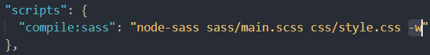

**IMPORTANT Note that if you want to keep SASS working you cannot close the command prompt where your script is running**

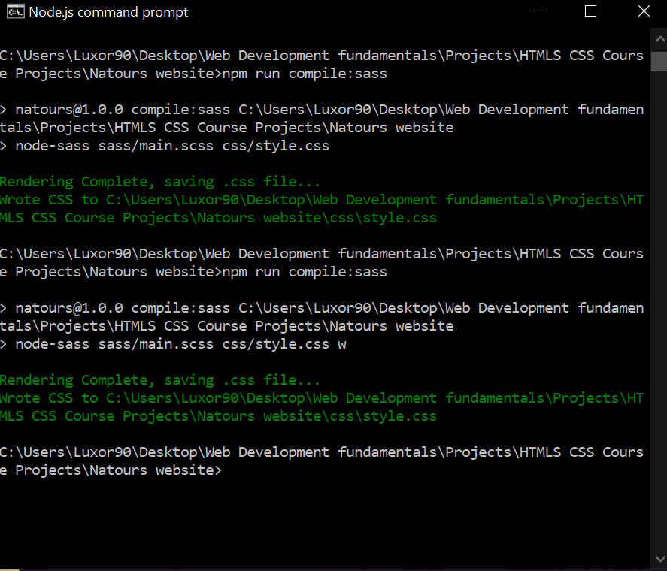

Figure 7CLOSING PROMPT == CLOSING SASS

Also, do not run any more commands on this prompt, as only one command can be interpreted at any time. This means that if you need to run any commands in the commandPrompt window, you can feel free to open up another command prompt alongside the one that is currently executing SASS.

## Installing SASS **live server** globally, not just in the current project

This basically means that we want to install this stuff on our computer =3

Still we will run this command in our project file^^

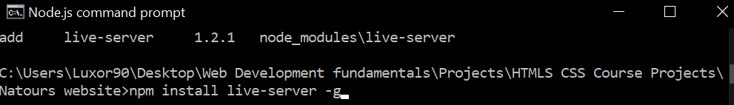

Local instal sufix would be **–instal** or sotmething similar, while for a global instalation we simply add the sufix **–g**

#### **Running the SASS live-server on our project**

To run this this global live server on our current project (directory) we have to simply enter into our project directory using the **Node.js command prompt**  and run the command: **live-server\** 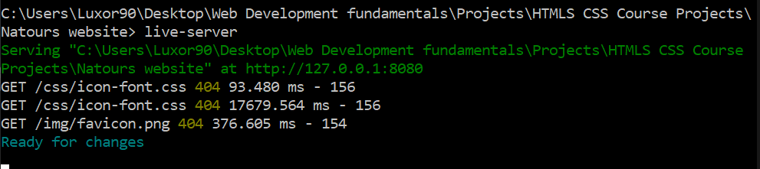The command code is in the first line above the green console log.

Note that to keep the live-server running we have to keep the command prompt running(can’t press exit X key on it)

**IMPORTANTE!!**

**To run SASS with Live-server you have to keep two command prompts on, one for SASS, the other for LIVE-SERVER**

Also, remember to run Command prompts as administrator

## **Additional notes on the selector specificity of the BEM model**

Notice how all of the classes denoted using the BEM model have a very low specificity.

The fact that each element has a class for itself means that most of all of our selectors have only a single class on them. This makes them incredibly easy to overwrite, and also, very hard to break, from the standpoint of specificity.

If all of our classes have a specificity (1) it is very easy to find the one that either has a higer importance or is declared lower in the cascade before our element.

This makes finding errors where some of our rules override each other incredibly easy.

**Also, since each and every element has its own separate class, it is very difficult to imagine a standard nesting structure within the BEM model.**

Standard SASS nesting structure:

.header{

  nav{

    ul{

      li{

      }

    }

  }

}

The BEM Model has a bit of a different nesting structure

Notice that we have a . **.header{…}** Block (BEM, Block/Element/Modifier) and two separate blocks that that have a class representing them as elements belonging to a common header block : **.header**__logo-box{…}, **.header**__logo{…}

In the header block we will nest each statement, selector that has the “header” block in their selector, writing (&) instead of the word (header) as (&) nested in an element denotes the parent element selector

**.header** {

  height: 95vh;   background-size: cover;

  background-position: top;   clip-path: polygon(0 0, 100% 0, 100% 90%, 0 100%);

  position: relative;

}

**THE TWO SASS BLOCKS THAT WE WANT TO NEST INSIDE THE .header(block)**

**.header**__logo-box {

  position: absolute;

  top: 4rem;

  left: 4rem;

}

**.header**__logo {

  height: 3.5rem;

}

#### **After nesting using the (&), notice that inside the**

#### **.header{ &__logo-box === .header__logo-box}**

**.header** {

  height: 95vh;   background-size: cover;

  background-position: top;   clip-path: polygon(0 0, 100% 0, 100% 90%, 0 100%);

  position: relative;

**&**__logo-box {

    position: absolute;

    top: 4rem;

    left: 4rem;

  }

**&**__logo {

    height: 3.5rem;

  }

}

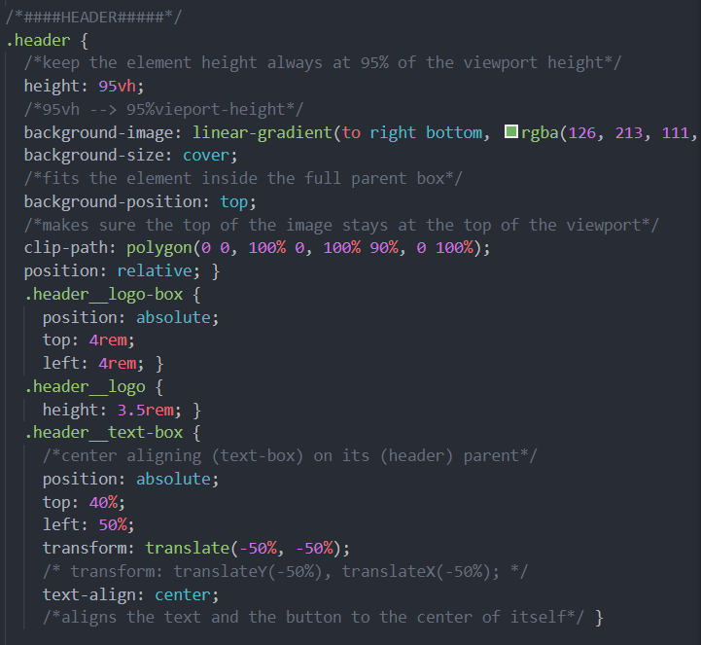**Side by side example :**

Figure 8 Post processed nested regular CSS code

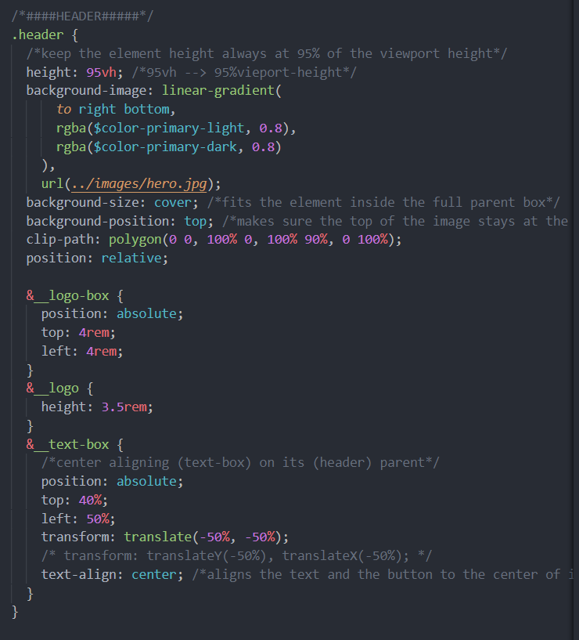

Figure 9 SCSS nested code (pre processing)

## **Implementing the CSS Architecture (7-1 principle)**

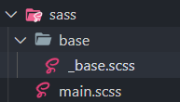The partial file is denoted by the prefix underscore(_base.scss)

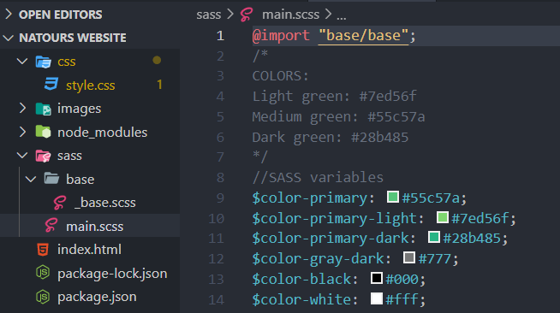

From the main.scss file we need to find the path to our partial _base.scss file. So from the home directory we enter the base folder and then the _base.scss file (there is no reason to write .scss extension)